Layer 1: short term

Layer 1: short term  COMMERCIALISING  Right now | just sell in the consumer wellness market, to test demand  NOT:  - diagnose dementia  - publish papers  - achieve 90% accuracy  - train ML models  Success metric is real consumer demand and user validation of the product —> people’s willingness to use and buy the product (and dementia detection is a later on benefit, see layer 2)  Features:  - Voice AI companion  - Daily conversations  - Including minimum questions eg have you taken your medications  - Session summaries  - Caregiver dashboard  - Long term trend display  - NO MORE risk score, instead maybe qualitative/by colours  - Recommendations  - Push notifications  - FAQ and guide  - Chatbot (to us but they dont know it, since its early stage, so they can directly ask us questions and we can answer)  - Feedback/Suggestions portal  All other features are secondary. (we will continuously get feedback from ppl too e.g. what other features would you like to have?)  - Elderly version (can be either on the smart mirror interface directly to the user, or a separate log-in for the app)  - This one also has cognitive exercises
Layer 2: LONG term  Getting a clinically validated product either by:  - Research partnership  - We develop & research | Option 1 (ideal): Research partnership  they will have the validated model and sg-specific dementia data  our goal then is to incorporate it into a mirror + UI/UX and bring it to consumers (main tech role)

Option 2: we develop ourselves
- Lengthy process
- Do you think you can?

REFLEXION
Product Design & Clinical Strategy
Consumer Product (Part 1) · Long-Term Clinical Direction (Part 2) | June 2026

PART 1  Consumer Product  Caregiver app UX/UI · Voice AI agent · MVP screen flows · Backend spec · Design principles | PART 2  Long-Term Clinical Direction  Speech biomarker ML research

⚠ CRITICAL STRATEGIC REFRAME BEFORE YOU READ EITHER PART: Caregivers do not want cognitive scores. They want to know: 'Is Mum okay today?' The entire consumer product should be designed around this single insight. Reflexion should feel like a companion for the elderly and a peace-of-mind service for their children — not a medical device.

PART 1 — Consumer Product Design Specification

1.1 Product Architecture — Three Components
Component | What It Is | Primary User
Mirror Companion | Physical device mounted on surface in elderly person's home. Runs voice AI agent. Shows date, weather, clock. No 'app' for elderly to open. | Elderly person (passive — they do not operate it)
Caregiver App | Mobile app (iOS + Android). Shows status of linked elderly. Receives alerts. Views summaries. | Adult child / family caregiver (daily check)
Admin/Onboarding Web | Web portal for initial setup: account creation, mirror linking, elderly profile creation. Used once. | Caregiver (setup only) / Operator (nursing home)

1.2 Mirror — Voice AI Agent Design

Voice Agent “Aria” Personality Spec — for Developer
Parameter | Spec | Implementation Note
Speech rate | Slow. Default 0.85× normal speed. | Configurable per user profile. Some elderly prefer normal speed. Allow caregiver to adjust.
Tone | Warm, calm, unhurried. Grandmother-like, not assistant-like. | System prompt: 'You are Aria, a warm and patient companion. Never rush. Always wait. Always affirm before moving on.'
Language | English default. Mandarin toggle. Singlish-tolerant. | Multilingual: English, Mandarin. Malay/Tamil Phase 2. Singlish and code-switching should not confuse transcription.
Silence handling | Wait 7–10 seconds before gentle re-prompt. Never cut off. | VAD threshold: configurable. Default 7-second wait. Single gentle re-prompt only: 'Take your time.'
Error handling | If mishear: 'I didn't quite catch that — could you say that again?' Once only, then move on. | Never repeat the question more than once. Never express frustration. Log mishear events for quality.
Affirmation style | 'Thank you, that's lovely.' / 'That sounds wonderful.' / 'I'd love to hear more.' | Do NOT affirm correctness of factual answers. Never say 'That's right!' — implies wrong answers exist.
Memory use | Reference prior sessions naturally: 'Last time you mentioned going to the market — did that happen?' | Requires session history retrieval in system prompt. Creates continuity and warmth.

Mirror Home Screen — Persistent Display
⬛ MIRROR HOME SCREEN — always visible when not in conversation
LAYOUT: Full-screen, minimal. Dark background (reduces glare anxiety). Single centered layout.
Left panel (60% of screen):  ▸ Current time — very large (72pt minimum)  ▸ Day and date — large (32pt)  ▸ Simple greeting: 'Good morning, Margaret'  ▸ Today's weather — icon + temperature only | Right panel (40%):  ▸ Soft pulsing microphone icon  (shows Aria is listening/ready)  ▸ 'Say hello to start'  ▸ Nothing else

WHY: Research shows elderly users are overwhelmed by information-dense screens. Clock + greeting + one prompt is the maximum before cognitive load becomes a barrier to engagement.

Daily Conversation Flow — The Core Product Loop
The daily conversation is 3–5 minutes. It should feel like talking to a kind friend who checks in every morning. It should NOT feel like a test. The speech captured during this conversation is the clinical data.
Stage | Aria Says | Cognitive Signal Captured | Design Rationale
1 Warm-up (30s) | Good morning [Name], it's lovely to see you. How are you feeling today? | Mood signal; speech initiation; response latency | Low-stakes entry. Orients user to date/time implicitly.
2 Yesterday recall (60s) | What did you have for dinner yesterday? / Did you sleep well? | Episodic memory; temporal orientation; narrative coherence | Recall disguised as natural conversation. No 'remember' framing.
3 Present / Planning (60s) | What are you planning to do today? / Is anyone visiting you this week? | Future planning; prospective memory; social connectedness | Captures executive function signals and social engagement.
4 Medication Reminder | Good afternoon [Name] — have you taken your afternoon medication yet? | Memory, caregiver adjunct
5* Reminiscence(60–90s)  2x per week | Tell me about a holiday you loved. / What was your favourite food as a child? | Semantic memory; language richness; lexical diversity; speech fluency | Generates the highest-quality and longest speech samples. Elderly enjoy this — creates habit.
6 Close (30s) | That sounds lovely, thank you so much for chatting with me today. Enjoy your morning! | Session completion signal | Positive close increases tomorrow's return rate.

Additional Interaction Modes (Beyond Daily Check-In)
Reminiscence Sessions (2× per week, optional)
Triggered by Aria or caregiver-initiated via app. 5–8 minute deeper conversation on a specific life topic:
• 'Tell me about your wedding day'
• 'What was your first job like?'
• 'Describe your favourite holiday as a child'
• 'Tell me about your children when they were young'
These generate the richest speech data for the research pipeline and are the interactions elderly users report enjoying most. Reminiscence therapy is independently validated as beneficial for cognitive engagement in elderly populations.

News & World Check-In (Daily, Optional)
Brief current events prompt: 'I heard it's going to be hot this week — are you keeping cool?' Not a quiz. Contextual current-events anchoring captures temporal orientation without feeling like a test.
Medication Reminder (High WTP Feature)
Aria: 'Good afternoon [Name] — have you taken your afternoon medication yet?' User responds yes/no. Caregiver app receives confirmation or alert. This is a top-3 WTP feature in caregiver research surveys.

Feature Flags to Exclude from MVP
❌ EXCLUDE from MVP Mirror | ✅ INCLUDE in MVP Mirror
• Cognitive score display on mirror  • 'Your memory score today is...'  • Facial emotion tracking display  • Brain training games  • Structured recall tests (list words → repeat)  • Any mention of 'dementia' or 'cognitive decline'  • Multiple interaction modes visible to user  • Complex menu navigation | • Time, date, weather display  • Warm greeting with name  • 5-minute daily conversation (Aria)  • Reminiscence prompts (2× per week)  • Confirmation of session to caregiver app  • Gentle missed-session detection (no interaction today)  • Multilingual toggle (English / Mandarin)  • Volume / speech rate adjustment via voice command

1.3 Caregiver App — Screen-by-Screen Design Specification

App Information Architecture
# | Screen | Purpose
1 | Home Dashboard | Overview of all linked elderly — status at a glance
2 | Individual Profile | Detailed view for one elderly person — today's summary + trend
3 | Trend History | 7-day and 30-day stability trend view
4 | Alerts | All alerts chronologically — tappable to take action
5 | Onboarding Flow | Account → elderly profile → mirror link
6 | Settings | Notification preferences, profile edit, alert thresholds
7 | Session Replay (audio/text) | Read or listen to today's conversation (opt-in)
9 | FAQ and guide
10 | Chatbot / Feedback portal

📱 SCREEN 1 — Home Dashboard (First Screen After Login)
LAYOUT: Icon grid. 1 column for ≤2 elderly. 2×2 grid for 3–4 elderly. Tap icon = go to Profile.
EACH ICON contains:
🟢 Grandma Lim  Doing well  Today, 8:15am | 🟡 Grandpa Tan  Quieter this week  Yesterday, 7:52am | 🔴 Grandma Chan  No interaction today  2 days ago ⚠

STATUS TEXT RULES — these are the only three states visible on the card:
•
•
•

WHY TRAFFIC LIGHTS ONLY: Caregiver cognitive load research shows that binary threshold alerts outperform dashboards with multiple metrics for driving action. A caregiver checking between meetings needs 2 seconds, not 2 minutes.

📱 SCREEN 2 — Individual Profile (Tap on a Card)
TOP SECTION — Status & Today
• Large status badge: 🟢 'Grandma Lim is doing well today'
• 'Last spoke: Today at 8:15am · Duration: 4 min 32 sec'
• '📞 Call Grandma' button — taps to dial her phone

TODAY'S SUMMARY — AI-generated plain English
"Grandma completed her morning conversation today. She sounded cheerful and mentioned she is planning to go to the wet market later. She recalled having fishball noodles for dinner yesterday. No changes from her usual pattern."

TOPICS MENTIONED (simple keyword chips — not clinical labels):
🛒 Market 🍜 Food 👨‍👩‍👧 Family 🌤 Weather

MIDDLE SECTION — This Week
• 7-day sparkline: simple bar chart — height = engagement duration each day. No numbers on chart. Color = status.
• 'Talked 5 of 7 days this week · Average duration 3m 45s'
• Trend label: 'Stable' / 'More engaged than last week' / 'Less engaged this week'

BOTTOM SECTION — Quick Actions
• 📞 Call now
• 📋 View full conversation summary (text)
• 📅 View 30-day trend
• ⚙ Adjust alert settings for this person

📱 SCREEN 3 — Trend History
This screen is for deeper review — not daily use. Caregiver taps 'View 30-day trend' from Profile.
• Single graph: 30 bars (one per day). Height = relative engagement duration. Color = Green/Yellow/Red by threshold.
• One sentence above the chart: 'Grandma has been consistently engaged over the past 30 days. No significant changes detected.'
• 'Engagement Score' NOT shown. No numbers except days.
• Toggle: 7 days / 30 days / 3 months
• Notable events timeline below graph: 'Dec 12 — Missed 2 sessions' / 'Dec 20 — Alert: reduced engagement'

FEATURE TO ADD IN V2 (NOT MVP): Cognitive Stability Score — a single 0–100 number with trend arrow. Only add this once you have validated that users understand and are not distressed by it. Do not add it to MVP.

📱 SCREEN 4 — Alerts
IMPORTANT: Alerts are the highest-value feature in the product. Every alert must:
• Say what happened in plain English — no jargon
• Tell the caregiver what it might mean
• Suggest an action
• Have one tap button to take that action

Alert Type | Message Text | Action Button
Missed routine (3 days) | Grandpa Tan hasn't had his morning chat for 3 days. This is unusual for him — it may be worth checking in. | 📞 Call now
Reduced engagement | Grandma Chan's conversations have been noticeably shorter this week compared to her usual pattern. | 📞 Call or 📝 Note for GP
Today — no interaction | Grandma Lim hasn't interacted with Aria today yet (it's now 11am). She usually does so by 9am. | 📞 Call now
Significant speech change | We noticed something different about Grandpa's speech today. This may or may not be significant — worth a call. | 📞 Call or 👨‍⚕️ Flag for review
Positive update | Grandma Lim had an unusually long and lively chat today — she seems happy! | (Positive — no action needed)

WHAT ALERTS TO NEVER SEND:
• 'Dementia risk score increased' — unvalidated, distressing, legally risky
• 'Cognitive performance: below baseline' — clinical language that terrifies without context
• 'Assessment failed: 3 of 5 recall items missed' — frames interaction as a test with failure

📱 SCREEN 5 — Onboarding Flow (One-Time Setup)
DESIGN PRINCIPLE: Onboarding must take under 5 minutes for someone who is not technical. If it takes longer, they will not complete it and you lose the user.
Step 1 — Account Creation (60s):
• Name, email, password, phone number
• Relationship to elderly person: 'I am caring for...' (child, sibling, spouse, other)
• Number of elderly to monitor: 1 / 2 / 3 / More

Step 2 — Elderly Profile (90s per person):
• Name (as they like to be called — not formal name)
• Age and gender
• Preferred language: English / Mandarin / Other
• Usual wake time (so system knows when to expect morning interaction)
• Any known medical conditions affecting speech or hearing (optional — no mandatory cognitive status entry)
• Photo upload (used on caregiver dashboard card — humanises the interface)
• Key topics they enjoy talking about: Family / Food / Travel / Work / Others (free text) → informs Aria's conversation prompts

Step 3 — Mirror Linking (60s):
• Scan QR code on the physical Reflexion device to link it to this elderly profile
• Name the mirror: 'Mirror 1 — Toa Payoh home'
E.g. Mirror 1 in Toa Payoh Home monitoring Grandpa 1 and Grandma 1, Mirror 2 in Bukit Timah Home monitoring Grandpa 2 and Grandpa 2
Elderly user creation and allocation to mirror and associated monitoring in app for both mirrors and 4 grandparents
Caregiver home dashboard will show 4 icons for 4 grandparents
• Test connection: tap 'Send test greeting' → Aria says good morning on the mirror

Step 4 — Notification Setup (30s):
• Enable push notifications (recommended)
• Choose alert sensitivity: 'Notify me about everything' / 'Only important changes' / 'Only urgent alerts'
• Preferred daily summary time: morning push at 9am / evening push at 7pm

📱 SCREEN 6 — Settings
Keep this simple. Settings are not a feature — they are the thing users go to when something is wrong.
• Notification preferences (per elderly person)
• Alert sensitivity threshold (low / medium / high)
• Aria speech rate (per elderly person): Slow / Normal / Fast
• Aria language per device: English / Mandarin
• Daily summary time
• Manage linked mirrors
• Manage elderly profiles
• Subscription and billing
• Privacy settings: enable/disable session summary storage
• Data export (V2)
• FAQ and guide
• Support / Help

1.4 Push Notification Design — The Most Important UX Surface
The push notification is where the product delivers its core value. Most users will not open the app daily. They will read the push. Design this as the primary product surface.
Notification Type | Example Text | Timing
Morning status (daily) | 🟢 Grandma Lim had her morning chat at 8:15am. She sounds well today. | 9:00am or customised
Missing interaction | ⚠ Grandpa Tan hasn't had his morning chat yet (it's now 10:30am). He usually does so by 9am. | 1.5h after usual time
3-day absence | 🔴 Grandpa Tan hasn't interacted with Aria for 3 days. This is unusual — consider calling him. | After 3 missed days
Weekly summary | 📊 This week: Grandma Lim — 6/7 days, stable. Grandpa Tan — 4/7 days, slightly less engaged. | Sunday evening
Positive signal | 😊 Grandma had a long, cheerful chat this morning — she talked about her grandchildren! | Immediate on detection
Significant change | ⚠ We noticed a change in Grandpa's usual pattern today. It may be worth a call. | Immediate on detection

1.5 Backend Specification — What the Developer Needs to Build

Data Pipeline
Layer | Function | Tech Stack (Recommended)
Voice capture | Record patient speech only (AI voice excluded via VAD). Store as WAV. 16kHz, 16-bit PCM. | Existing Pi pipeline (pi_audio_bridge.py). Echo fix required (directional mic).
Transcription | Convert speech to text per session. | OpenAI Whisper via Realtime API (existing). Store full transcript per session.
Session summary generation | Generate 2–3 sentence plain-English summary of conversation for caregiver app. | GPT-4o prompt: 'Summarise this conversation in 2–3 warm, plain-English sentences for a concerned adult child. Do not mention cognitive scores.'
Engagement metrics | Compute: session duration, word count, response latency, number of exchanges. | Calculate from transcript + audio timestamps. Store per session.
Baseline modelling | Build 14-day rolling baseline per user for each metric. Flag sessions outside 2 SD as Yellow; outside 3 SD as Red. | Python: rolling mean + SD calculation. Run nightly.
Status determination | Determine Green/Yellow/Red for daily card. | Rule-based: Green = session complete + within baseline. Yellow = session short or missed today. Red = 3+ days missed or significant deviation.
Alert generation | Trigger push notification for Yellow/Red states. | Firebase Cloud Messaging (FCM) for iOS + Android.
Caregiver dashboard API | REST API serving profile, session, trend, alert data to mobile app. | Node.js / FastAPI. JWT auth. HTTPS only.
Data storage | Secure storage for audio, transcripts, metrics, profiles. | AWS S3 (audio, encrypted) + PostgreSQL (structured data). Singapore region.

Wizard-of-Oz Backend for MVP Validation
For the August MVP, the backend for session summary and status can be partially human-operated. This is the 'Wizard-of-Oz' approach: a human (you, your team member, an intern) reviews the transcript and writes the daily summary. The caregiver does not know.
When to use Wizard-of-Oz: Use it for the first 20–30 users. It lets you move fast, tests the caregiver UX without perfecting the AI, and surfaces what caregivers actually find useful in the summary before you automate it. Graduate to automated summaries once the format is validated.

1.6 Design Principles
These are grounded in published research on technology acceptance in elderly and caregiver populations (UTAUT, TAM-2, aged care deployment literature):
For the Elderly
• NEVER use the word 'test', 'assessment', 'screening', 'cognitive', or 'dementia' anywhere the elderly user sees
• Frame every interaction as companionship: 'Good morning, I'd love to hear about your day' not 'Time for your daily check-in'
• Large text minimum 18pt. High contrast. Maximum 2 taps to any function. Voice-first.
• Slow down: configurable speech rate. Pause and wait. Repeat if needed. Never rush.
• Consistency is safety: same greeting, same time, same voice every day. Elderly users with early MCI are distressed by changes in routine — your UX must be unchanged session to session.
• Positive reinforcement only: 'Lovely, thank you!' not 'You said three words, the target was five.'

For the Caregiver
• Maximum one screen of information per visit. If they need to scroll to understand, you have failed.
• Status, not data: Green/Yellow/Red with one sentence. Not charts unless they request them.
• Push notifications are the product: a caregiver checking an app daily is unlikely; a caregiver receiving a morning push that says 'Mum had a good morning today' will feel the value every day.
• Alerts only for change, not for normal: send a push when something is different. Silence = everything is fine.
• Empathy-first language: 'Grandpa seemed a little quieter today — it may be worth giving him a call' not 'Speech engagement: 34% below baseline'.
• Enable action: every alert should have a 'Call' or 'Message care team' button directly below it.

TIMELINE
At the August booth, a caregiver should be able to:
- Create account
- Add elderly profile
- Have elderly complete conversation
- Receive AI summary
- View trends
- Receive alerts

Super tight timeline to august, lets discuss this

Week | Dates | Deliverable | What Must Be Working By End Of Week
W1:  (CHECK IN ON 12 JUNE) | 5–12 Jun | Backend Foundation | User accounts, caregiver profiles, elderly profiles, authentication, cloud/database setup
 |  | Voice AI Companion (Aria) | Elderly can start conversation, speech-to-text works, GPT responds, transcript saved
 |  | Conversation Intelligence | Session summaries generated, topic extraction, conversation history stored
 |  | Caregiver Dashboard V1 | Home dashboard, elderly profile page, summary display, Green/Yellow/Red status
 |  | Monitoring Engine | Track duration, word count, response latency, baseline comparison, trend graphs
 |  | Notifications & Alerts | Push notifications, missed check-ins, unusual activity alerts, positive updates
 |  | Integration Testing | Full user flow working end-to-end, onboarding flow, bug fixing
SUBMISSION TO MBEC
W1  (CHECK IN) | 12-18 Jun | App + voice | Feedback + improvements
W3  (CHECK IN) | 19–26 Jun | Pilot Preparation | Demo mode, analytics, feedback collection, booth readiness
W4 | 26 Jun–3 Jul
W5 | 3–10 Jul
W6 | 10–17 Jul
W7 | 17–24 Jul
W8 | 24–31 Jul
Buffer | 1–15 Aug

Design of the app (aesthetics)

OPTION 1 — Warm Sage / Bronze / Terracotta (go w this first)  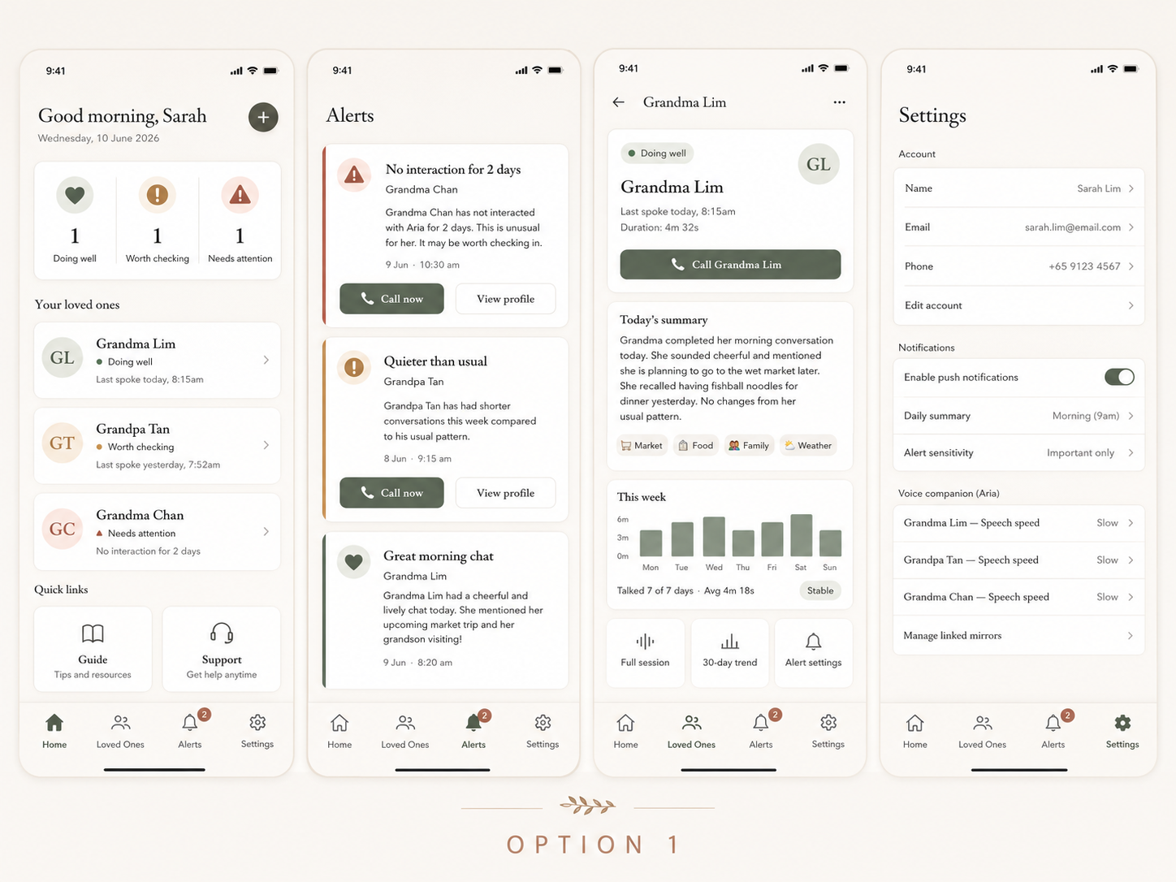  1. Overall feel  Reference style:  - Warm family caregiving app  - Calm, premium, trustworthy  - Apple Health / Withings, but softer and more human  - Not clinical  - Not colourful / cartoonish  - Not default AI app  2. Colour palette  App background  background: "#F7F3EC"  Use this instead of pure white or light grey.  Cards  cardBackground: "#FFFFFF"  cardBorder: "#E8DFD3"  Main text  textPrimary: "#25231F"  textSecondary: "#6F6A61"  textMuted: "#9B948A"  Primary brand colour  Use deep olive / sage instead of bright green or blue.  primary: "#596C56"  primaryDark: "#3F4D3D"  primaryLight: "#EEF2EC"  Use this for:  - Primary buttons  - Active bottom nav  - Call buttons  - Toggles  - Selected states  Status colours  Do not use traffic-light green/yellow/red.  Use these muted colours instead:  doingWell: "#596C56"  doingWellBg: "#EEF2EC"  worthChecking: "#9A7A45"  worthCheckingBg: "#F6EFE2"  needsAttention: "#9B5F4E"  needsAttentionBg: "#F6E9E5"  Meaning:  - Doing well = muted sage  - Worth checking = bronze / warm taupe  - Needs attention = muted terracotta  3. Typography  Use this font direction:  headingFont: "Georgia / Newsreader / Libre Baskerville / Playfair Display"  bodyFont: "Inter / system sans-serif"  If you want simple implementation, use:  headingFont: "Georgia"  bodyFont: "Inter"  Typography sizes:  screenTitle: 26px, weight 500  sectionTitle: 17px, weight 600  cardTitle: 16px, weight 600  body: 14px, weight 400  caption: 12px, weight 400  buttonText: 14px, weight 600  bottomNavLabel: 11px, weight 500  Line heights:  headingLineHeight: 32px  bodyLineHeight: 20px  captionLineHeight: 16px  4. Card styling  Main cards:  borderRadius: 16  backgroundColor: "#FFFFFF"  borderWidth: 1  borderColor: "#E8DFD3"  padding: 16  Shadow:  shadowColor: "#000000"  shadowOpacity: 0.04  shadowRadius: 10  shadowOffset: { width: 0, height: 4 }  elevation: 2  Avoid:  - 24–32px overly rounded cards  - heavy shadows  - grey card backgrounds  - random coloured cards  5. Buttons  Primary button  height: 48  borderRadius: 12  backgroundColor: "#596C56"  textColor: "#FFFFFF"  fontSize: 14  fontWeight: 600  Example:  Call Grandma Lim  Secondary button  height: 44  borderRadius: 12  backgroundColor: "#FFFFFF"  borderWidth: 1  borderColor: "#D8D0C5"  textColor: "#25231F"  fontSize: 14  fontWeight: 600  Examples:  View profile  View summary  Alert settings  6. Status badges  Do not use bright traffic-light badges.  Use small text pills with muted colours.  Doing well  backgroundColor: "#EEF2EC"  textColor: "#596C56"  dotColor: "#596C56"  Text:  Doing well  Worth checking  backgroundColor: "#F6EFE2"  textColor: "#9A7A45"  dotColor: "#9A7A45"  Text:  Worth checking  Needs attention  backgroundColor: "#F6E9E5"  textColor: "#9B5F4E"  dotColor: "#9B5F4E"  Text:  Needs attention  Pill style:  borderRadius: 999  paddingVertical: 5  paddingHorizontal: 10  fontSize: 12  fontWeight: 600  7. Icons  Use Lucide icons only.  iconSize: 20  iconStrokeWidth: 1.75  iconColorDefault: "#6F6A61"  iconColorActive: "#596C56"  Icon mapping:  Home → Home  Loved Ones → Users or HeartHandshake  Alerts → Bell  Guide → BookOpen  Settings → Settings  Call → Phone  View summary → FileText  Trend → BarChart3  Full session → AudioLines  Alert settings → BellRing  Support → Headphones  Add → Plus  Back → ArrowLeft  More → MoreHorizontal  No emojis in structural UI.  8. Bottom navigation  Use 5 tabs:  Home  Loved Ones  Alerts  Guide  Settings  Style:  navHeight: 72  navBackground: "#FFFFFF"  navBorderTop: "#E8DFD3"  activeColor: "#596C56"  inactiveColor: "#8E877C"  labelFontSize: 11  iconSize: 21  Active tab:  - muted sage icon  - muted sage label  - no coloured bubble background  Inactive tabs:  - taupe grey icon  - taupe grey label  9. Avatar styling  Use initials, not just “G”.  avatarSize: 48  avatarBorderRadius: 999  avatarBackground: "#F0EDE6"  avatarTextColor: "#4B433A"  avatarFontSize: 18  avatarFontWeight: 500  Examples:  Grandma Lim → GL  Grandpa Tan → GT  Grandma Chan → GC  For status-linked avatars:  - Doing well avatar tint: #EEF2EC  - Worth checking avatar tint: #F6EFE2  - Needs attention avatar tint: #F6E9E5  10. Layout spacing  Use this consistently:  screenPaddingHorizontal: 20  screenPaddingTop: 20  sectionGap: 22  cardGap: 12  cardPadding: 16  rowGap: 10  smallGap: 8  Cards should align to the same left and right margin.  11. Home screen structure  Use:  Good morning, Sarah  Wednesday, 10 June 2026  [Status summary card]  1 Doing well | 1 Worth checking | 1 Needs attention  Your loved ones  [GL] Grandma Lim  Doing well  Last spoke today, 8:15am  [GT] Grandpa Tan  Worth checking  Last spoke yesterday, 7:52am  [GC] Grandma Chan  Needs attention  No interaction for 2 days  Quick links  [Guide] [Support]  12. Alerts screen structure  Alert cards should use a subtle left border instead of loud full-colour cards.  alertCardBorderLeftWidth: 4  Colours:  doingWellLeftBorder: "#596C56"  worthCheckingLeftBorder: "#9A7A45"  needsAttentionLeftBorder: "#9B5F4E"  Example alert card:  No interaction for 2 days  Grandma Chan  Grandma Chan has not interacted with Aria for 2 days. This is unusual for her. It may be worth checking in.  9 Jun · 10:30am  [Call now] [View profile]  13. Profile screen structure  Grandma Lim  [Doing well] [GL]  Last spoke today, 8:15am  Duration: 4m 32s  [Call Grandma Lim]  Today’s summary  Grandma completed her morning conversation today...  [Market] [Food] [Family] [Weather]  This week  [Simple bar chart]  Talked 7 of 7 days · Avg 4m 18s  [Stable]  [Full session] [30-day trend] [Alert settings]  14. Chart styling  Use muted sage bars.  chartBarColor: "#8FA08A"  chartAxisText: "#8E877C"  chartBackground: "#FFFFFF"  Avoid:  - bright green bars  - finance dashboard style  - too many numbers  - gridlines unless very subtle  15. Text wording  Replace:  Patients → Loved ones  Patient profile → Loved one profile  Risk → Status  Assessment → Conversation  Cognitive score → Today’s summary  Abnormal → Needs attention  Warning → Worth checking / Needs attention  Do not use:  dementia  diagnosis  screening  clinical assessment  cognitive risk  patient monitoring | OPTION 3 — Cream / Taupe / Dusty Plum  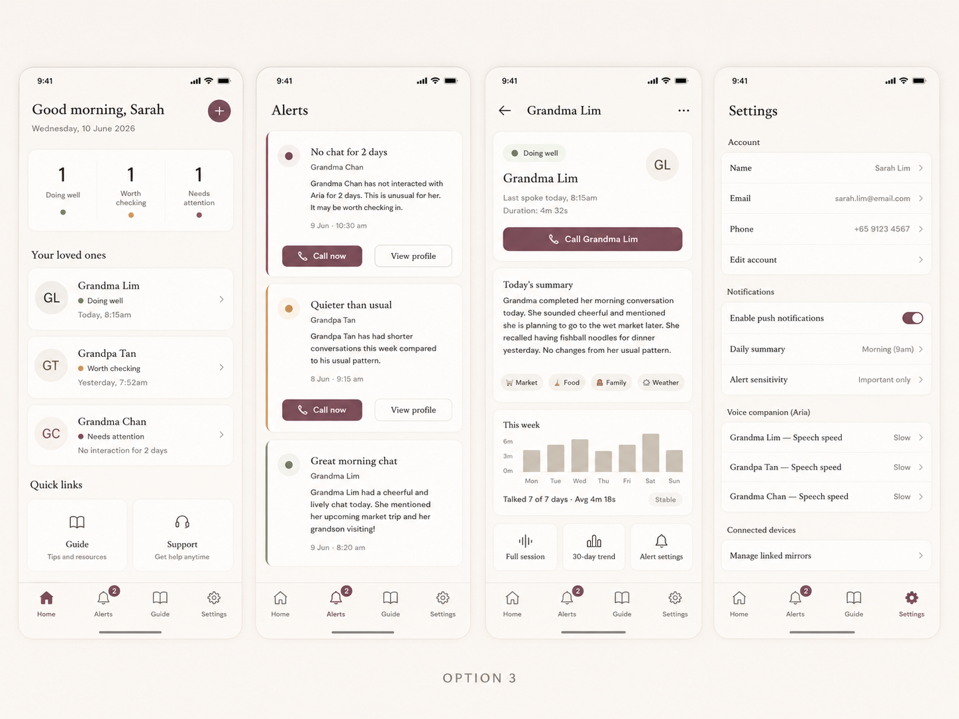  1. Overall feel  Reference style:  - Boutique wellness app  - Premium caregiving  - Warm, calm, almost luxury  - Less medical  - More elegant and editorial  - Still simple enough for caregivers  2. Colour palette  App background  background: "#F8F3EC"  Cards  cardBackground: "#FFFFFF"  cardBorder: "#E7DED2"  Main text  textPrimary: "#2B2522"  textSecondary: "#756C64"  textMuted: "#A69C92"  Primary brand colour  Use dusty plum / rosewood instead of green or blue.  primary: "#87566A"  primaryDark: "#673F50"  primaryLight: "#F3E8ED"  Use this for:  - Primary buttons  - Active bottom nav  - Add button  - Toggles  - Selected states  Neutral accents  taupe: "#B9AA99"  mushroom: "#D8CFC3"  espresso: "#2B2522"  warmSand: "#EFE7DB"  Status colours  Keep statuses mostly neutral with small accent dots.  doingWell: "#66735D"  doingWellBg: "#F0F3ED"  worthChecking: "#B2844B"  worthCheckingBg: "#F6EFE5"  needsAttention: "#87566A"  needsAttentionBg: "#F3E8ED"  Meaning:  - Doing well = muted olive dot  - Worth checking = muted ochre dot  - Needs attention = dusty plum dot  3. Typography  Use the same elegant font direction as Option 1.  headingFont: "Georgia / Newsreader / Libre Baskerville"  bodyFont: "Inter / system sans-serif"  Simple implementation:  headingFont: "Georgia"  bodyFont: "Inter"  Typography sizes:  screenTitle: 26px, weight 500  sectionTitle: 17px, weight 600  cardTitle: 16px, weight 600  body: 14px, weight 400  caption: 12px, weight 400  buttonText: 14px, weight 600  bottomNavLabel: 11px, weight 500  4. Cards  backgroundColor: "#FFFFFF"  borderRadius: 16  borderWidth: 1  borderColor: "#E7DED2"  padding: 16  Shadow:  shadowColor: "#000000"  shadowOpacity: 0.035  shadowRadius: 10  shadowOffset: { width: 0, height: 4 }  elevation: 2  5. Buttons  Primary button  height: 48  borderRadius: 12  backgroundColor: "#87566A"  textColor: "#FFFFFF"  fontSize: 14  fontWeight: 600  Secondary button  height: 44  borderRadius: 12  backgroundColor: "#FFFFFF"  borderWidth: 1  borderColor: "#D8CFC3"  textColor: "#2B2522"  fontSize: 14  fontWeight: 600  6. Status badges  For Option 3, avoid large coloured status badges. Use neutral pills with tiny dots.  Pill base:  backgroundColor: "#F4F0EA"  borderRadius: 999  paddingVertical: 5  paddingHorizontal: 10  fontSize: 12  fontWeight: 600  textColor: "#4B403A"  Dot colours:  doingWellDot: "#66735D"  worthCheckingDot: "#B2844B"  needsAttentionDot: "#87566A"  Text:  Doing well  Worth checking  Needs attention  7. Icons  Use Lucide icons.  iconSize: 20  iconStrokeWidth: 1.75  iconColorDefault: "#756C64"  iconColorActive: "#87566A"  Icon mapping:  Home → Home  Loved Ones → Users or HeartHandshake  Alerts → Bell  Guide → BookOpen  Settings → Settings  Call → Phone  View summary → FileText  Trend → BarChart3  Full session → AudioLines  Alert settings → BellRing  Support → Headphones  Add → Plus  Back → ArrowLeft  More → MoreHorizontal  No emojis.  8. Bottom navigation  navHeight: 72  navBackground: "#FFFFFF"  navBorderTop: "#E7DED2"  activeColor: "#87566A"  inactiveColor: "#8D8278"  labelFontSize: 11  iconSize: 21  9. Avatar styling  avatarSize: 48  avatarBorderRadius: 999  avatarBackground: "#F0EAE2"  avatarTextColor: "#4A403A"  avatarFontSize: 18  avatarFontWeight: 500  Examples:  Grandma Lim → GL  Grandpa Tan → GT  Grandma Chan → GC  10. Layout spacing  screenPaddingHorizontal: 20  screenPaddingTop: 20  sectionGap: 22  cardGap: 12  cardPadding: 16  rowGap: 10  smallGap: 8  11. Home screen  Use this structure:  Good morning, Sarah  Wednesday, 10 June 2026  [Status summary card]  1 Doing well | 1 Worth checking | 1 Needs attention  Your loved ones  [GL] Grandma Lim  Doing well  Today, 8:15am  [GT] Grandpa Tan  Worth checking  Yesterday, 7:52am  [GC] Grandma Chan  Needs attention  No interaction for 2 days  Quick links  [Guide] [Support]  Important: the status row should use tiny coloured dots, not big coloured icons.  12. Alerts screen  Use thin left borders and small status dots.  alertCardBorderLeftWidth: 3  Colours:  doingWellLeftBorder: "#66735D"  worthCheckingLeftBorder: "#B2844B"  needsAttentionLeftBorder: "#87566A"  Primary alert action button should be plum:  backgroundColor: "#87566A"  textColor: "#FFFFFF"  Example:  No chat for 2 days  Grandma Chan  Grandma Chan has not interacted with Aria for 2 days. This is unusual for her. It may be worth checking in.  [Call now] [View profile]  13. Profile screen  Grandma Lim  [Doing well] [GL]  Last spoke today, 8:15am  Duration: 4m 32s  [Call Grandma Lim]  Today’s summary  Grandma completed her morning conversation today...  [Market] [Food] [Family] [Weather]  This week  [Simple muted taupe bar chart]  Talked 7 of 7 days · Avg 4m 18s  [Stable]  [Full session] [30-day trend] [Alert settings]  14. Chart styling  Use taupe bars, not green.  chartBarColor: "#B9AA99"  chartAxisText: "#8D8278"  chartBackground: "#FFFFFF"  stableBadgeBg: "#F4F0EA"  stableBadgeText: "#66735D"  15. Text wording  Replace:  Patients → Loved ones  Your Patients → Your loved ones  Patient profile → Loved one profile  Risk → Status  Assessment → Conversation  Cognitive score → Today’s summary  Abnormal → Needs attention  Warning → Worth checking / Needs attention  Do not use:  dementia  diagnosis  clinical  screening  cognitive risk  patient monitoring  medical alert

METRICS

Doing well
- Completed check-in today
- Check-in time is within usual routine. what is within the usual routine?
- No missed-day streak. How long is streak
- Engagement frequency similar to baseline. specifics

Worth checking
- Missed 1–2 days
- Check-in is much later than usual. What is much later
- Approached mirror but did not complete check-in repeatedly. Can implement much later with face integration
- Engagement dropped noticeably for 2–3 days. specifics
- Unusual pattern, e.g. using mirror at odd hours repeatedly. Specifics? What is unusual pattern

Needs attention
- Missed 3+ days
- No mirror interaction for 3+ days. Can implement much later with face integration
- Repeated failed/incomplete check-ins. specifics
- Missed medication/routine reminders plus missed check-ins. specifics
- Caregiver manually flags concern. What does this look like?
- New: if conversations have no words. Specifics? Is it the latest conversation with no words? All conversations today with no words?

Current for simplicity

Doing well
- Completed check-in today

Worth checking
- Missed 1–2 days

Needs attention
- Missed 3+ days

smart mirror interface
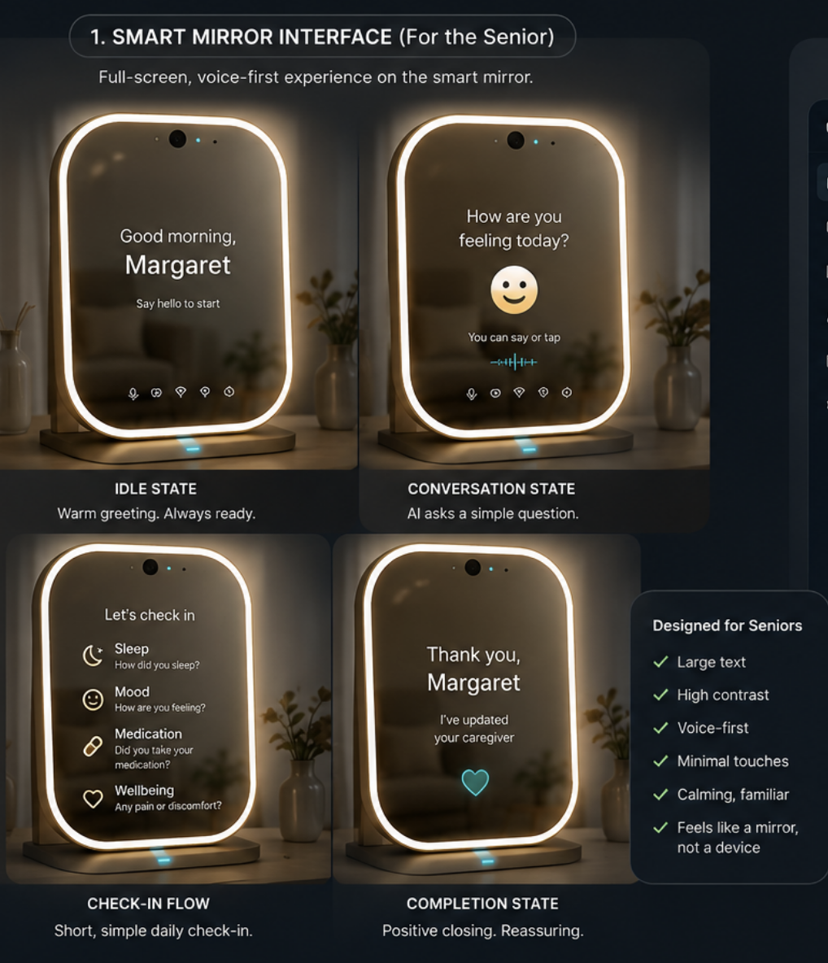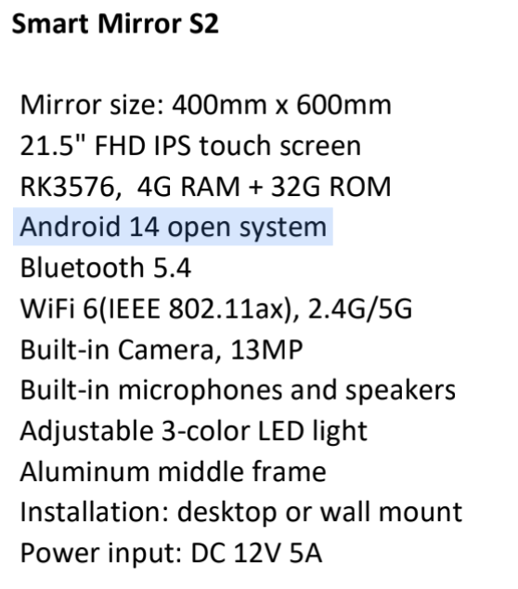

Updated metrics
REFLEXION
Status Metric Technical Specification
Caregiver App · 🟢 Doing Well / 🟡 Worth Checking / 🔴 Needs Attention

1. Design Principles Before You Write a Line of Code

1.1 The Two Hardest Problems to Avoid
Problem | What It Looks Like | How We Avoid It
Alert fatigue | Too many alerts → caregiver ignores them all → safety incident | Only alert on PATTERNS across multiple days, not single-session anomalies. One alert per metric per 48 hours maximum. Suppress amber if red is already active.
False positives from normal variation | Bad day → amber alert → caregiver panics → distrust product | All thresholds use intra-individual rolling baselines, not population norms. Single-day anomaly = nothing. 2–3 day pattern = amber. 3+ day pattern = red.

1.2 The Baseline Period — Nothing Fires Before This
CRITICAL: No status alert (amber or red) should fire until the baseline period is complete. Before baseline completion, show ⚪ 'Getting to know [Name]' with a progress indicator. Engagement-only metrics (completed / not completed today) still apply from Day 1.

Parameter | Value | Rationale
Baseline window | Rolling 14 calendar days | 14 days captures weekly routine variation (e.g., weekends vs weekdays). Industry standard for remote elderly monitoring calibration (Lively, 2024; BMC Geriatrics, 2025).
Minimum sessions before baseline is valid | 7 completed sessions | Prevents a sparse first 2 weeks from producing a meaningless baseline. If day 14 arrives with <7 sessions, extend baseline period until 7 sessions are collected.
Baseline recomputation | Every 7 days (rolling update) | Allows baseline to adapt gradually as the person's health and routine naturally evolve. Uses Exponentially Weighted Moving Average (EWMA, α = 0.1) so recent sessions carry slightly more weight.
Session count displayed to caregiver | 'Learning [Name]'s routine — [N] of 7 sessions recorded' | Transparent. Caregiver understands why no alerts are firing yet.
Status during baseline period | ⚪ ESTABLISHING (no green/amber/red) | Only show: session completed today (✓) or not (✗). No trend data.

1.3 Status Priority Rule
Status is determined by evaluating ALL active metrics and assigning the highest-severity status triggered by ANY metric. Red overrides Amber; Amber overrides Green.
Priority | Rule | Logic
1 (highest) | 🔴 NEEDS ATTENTION | If ANY metric meets a Red criterion → status = Red. Stop evaluating.
2 | 🟡 WORTH CHECKING | If NO metric meets Red, but ANY metric meets Amber → status = Amber.
3 | 🟢 DOING WELL | If NO metric meets Red or Amber → status = Green.
0 (base) | ⚪ ESTABLISHING | If baseline period not complete → status = Establishing. Overrides all others.

1.4 What to Build
 | Metric | Requires
M1 | Completed session today (binary) | Session end event
M2 | Missed day streak (consecutive days with no session) | Session log + date diff
M3 | Session time vs usual window | Session timestamps + baseline
M4 | Session duration (user speech time) | Audio duration tracking
M5 | Weekly engagement frequency vs baseline | Session count + rolling baseline
M6 | Session abandonment (started but incomplete) | VAD + turn-count tracking
M7 | Total words per session (word count) | ASR transcript + word count
M8 | Words per minute (speech rate) | ASR + audio duration
M9 | Near-silent session (words < threshold) | ASR + word count
M10 | Unusual time pattern (late night / early morning sessions) | Session timestamps
M11 | Type-Token Ratio (lexical diversity) | ASR + NLP tokenization
M12 | Disfluency rate (um/ah/er per minute) | ASR + disfluency tagger
M13 | Mean response latency | VAD timestamps + prompt timestamps

2. Tier Definitions

🟢  🟢 DOING WELL | Parent is following their usual routine. Nothing unusual detected.  FIRE WHEN: ALL of the following are true: (a) session completed today or within past 24h, AND (b) no metric in the Amber or Red range across all active metrics.

🟡  🟡 WORTH CHECKING | Something is a little different. Not urgent, but worth a call today.  FIRE WHEN: Baseline established AND no Red criteria met AND AT LEAST ONE Amber criterion met across any active metric.

🔴  🔴 NEEDS ATTENTION | Something significant has changed. Please reach out soon.  FIRE WHEN: Baseline established AND AT LEAST ONE Red criterion met across any active metric.

Status | Primary Push Notification | Card Display Text
⚪ Establishing | 'Getting to know [Name] — [N] of 7 sessions recorded.' | 'Learning routine...'
🟢 Doing Well | (Sent once daily at configured time) 'Grandma Lim had her morning chat at 8:15am. She seems well today.' | 'Doing well · Today 8:15am'
🟡 Worth Checking | Sent immediately when threshold first crossed: 'Grandpa Tan's conversations have been shorter than usual for the past 2 days. Might be worth a call today.' | 'Worth checking · [Key reason]'
🔴 Needs Attention | Sent immediately: 'Grandma Chan hasn't interacted with Aria for 3 days. This is unusual — please consider calling or checking in.' | 'Needs attention · [Key reason] ⚠'

3. MVP Metrics — Full Specification

M1 — Session Completion (binary)
M1 — Session Completion
Definition: A session is counted as COMPLETED if: user speech is detected for ≥ 30 cumulative seconds AND ≥ 3 exchanges occur (exchange = Aria prompt → user response ≥ 3 words). A session is INCOMPLETE if the mirror activated (any user speech detected) but the above criteria are not met. A session is ABSENT if no user speech detected within the expected interaction window for that day.
Formula / Computation: completed = (total_user_speech_seconds ≥ 30) AND (turn_count ≥ 3) incomplete = any_user_speech_detected AND NOT completed absent = NOT any_user_speech_detected for the day
🟢 DOING WELL Session completed today (at any time before midnight). OR session completed within past 24h (if user does session after midnight but before usual wake window).
🟡 WORTH CHECKING Session incomplete today AND was also incomplete or absent yesterday (2 consecutive days of no completion). OR 2 incomplete sessions in any 7-day window.
🔴 NEEDS ATTENTION No completed session in 3+ consecutive calendar days.

M2 — Missed Day Streak
M2 — Consecutive Days Without a Completed Session
Definition: Count of consecutive calendar days where M1 = absent OR incomplete. Reset to 0 whenever a completed session occurs. A 'caregiver-flagged away day' (see Section 5.3) does not count toward the streak.
Formula / Computation: streak = 0 for each day d in reverse-chronological order: if completed_session(d) OR flagged_away(d): break else: streak += 1
🟢 DOING WELL streak = 0 (session completed today or yesterday within 24h window).
🟡 WORTH CHECKING streak = 2 consecutive days. Fire amber alert on Day 2 at 2pm (if no session by 2pm and 24h have passed since last session).
🔴 NEEDS ATTENTION streak ≥ 3 consecutive days. Fire red alert at 9am on Day 3 and again at 6pm if no session occurs.

M3 — Session Time vs Usual Window (Routine Adherence)
M3 — Time of Day Relative to Personal Baseline Window
Definition: Collect session start timestamps (time_of_day in minutes from midnight) from the first 14 sessions. Compute: mean_time = mean(session_start_times); sd_time = std(session_start_times). Define usual_window_start = mean_time − max(2×sd_time, 90) and usual_window_end = mean_time + max(2×sd_time, 90). Cap the window at ±180 minutes from mean regardless of SD. Update rolling every 7 days using EWMA (α = 0.1). 'Unusual hours' = 10pm–5am (22:00–05:00 in 24h).
Formula / Computation: window_low = mean_time − max(2 × sd_time, 90) [minutes from midnight] window_high = mean_time + max(2 × sd_time, 90) both capped: window_low ≥ (mean_time − 180), window_high ≤ (mean_time + 180) session_on_time = window_low ≤ session_start ≤ window_high unusual_hours = session_start < 300 OR session_start > 1320 [before 5am or after 10pm]
🟢 DOING WELL Session completed AND session_on_time = true.
🟡 WORTH CHECKING Session completed BUT session_start is outside usual window on 2+ completed sessions within 7 days (more than max(2σ, 90 minutes) from mean). Example: grandma usually interacts at 8am (σ=15min → window 7:30–8:30am), but over 2+ days she interacted at 11am, 3pm and 1pm respectively. → Amber.
🔴 NEEDS ATTENTION 3+ sessions in unusual hours (10pm–5am) within any 7-day rolling window. This is a persistent sleep/routine disruption signal. NOTE: this is a PATTERN flag, not a single-session flag.

M4 — Session Duration (User Speech Time)
M4 — Total Active User Speech Time Per Session [🟢 MVP]
Definition: Total seconds of user speech audio in the session (AI speech excluded). Not total session clock time. Compute from VAD-segmented audio. Baseline = EWMA of speech_seconds across last 14 completed sessions (α=0.1). Use 7-session rolling average for comparison to smooth day-to-day variation.
Formula / Computation: speech_seconds(session) = sum(duration of all user VAD segments in session) baseline_speech = EWMA(speech_seconds, last 14 sessions, α=0.1) rolling_7_avg = mean(speech_seconds, last 7 completed sessions) ratio = rolling_7_avg / baseline_speech
🟢 DOING WELL ratio ≥ 0.80 (within 80% of baseline). OR session today with ratio ≥ 0.80.
🟡 WORTH CHECKING ratio between 0.55 and 0.79 for 2+ consecutive completed sessions. Example: grandma usually speaks 180 seconds/session; last 2 sessions she spoke 95 and 88 seconds (52% and 49% → both below 0.55 → Amber after 2nd session).
🔴 NEEDS ATTENTION ratio < 0.50 for 3+ consecutive completed sessions. OR any single session with speech_seconds < 20 (near-silent) that occurs on 2+ occasions in any 7-day window.
Research basis: Dodge et al. (2020, Current Alzheimer Research) found that proportion of words in free conversation was a sensitive social marker of MCI. Session duration is the proxy metric available without full NLP: shorter speech duration = less verbal engagement = early signal worth flagging. The 80% threshold is conservative by design — normal day-to-day variation in speech length is high, so only sustained reduction should trigger alerts. The 50% threshold for red ensures only clinically meaningful drops fire the alert.

M5 — Weekly Engagement Frequency vs Baseline
M5 — Sessions Completed per 7-Day Rolling Window vs Baseline [🟢 MVP]
Definition: Count completed sessions in the rolling 7-day window (today minus 6 days). Baseline_weekly = average sessions per 7-day window from the first 14-day baseline period. If baseline_weekly < 3 (very low-engagement person), use 3 as floor for amber/red calculation to avoid over-sensitivity.
Formula / Computation: sessions_7d = count(completed sessions in last 7 calendar days) baseline_weekly = mean sessions/week from baseline period baseline_floor = max(baseline_weekly, 3) freq_ratio = sessions_7d / baseline_floor
🟢 DOING WELL freq_ratio ≥ 0.80 (completed ≥ 80% of typical weekly sessions).
🟡 WORTH CHECKING freq_ratio between 0.50 and 0.79 for this 7-day window. Example: grandpa usually does 5 sessions/week; this week he has done 2 (40% → Red, not Amber — use Red thresholds below). 3 sessions = 60% → Amber.
🔴 NEEDS ATTENTION freq_ratio < 0.50 AND this is the second consecutive 7-day window below 0.50. Note: M2 (streak) will typically fire Red before M5 does for very low engagement — M5 catches gradual, non-consecutive drop-off that streak misses.
Research basis: VAS longitudinal speech study (Qi et al., 2024, arXiv) demonstrated that incorporating session history across multiple time points improved MCI detection F1-score from 58.6% to 71.2%. Weekly frequency is the simplest longitudinal signal: sustained reduction in voluntary interaction is both a quality-of-life signal and a cognitive engagement signal.

4. Phase 2 Metrics — Full Specification (Build After MVP Validated)

M6 — Session Abandonment
M6 — Started But Not Completed [🟡 Phase 2]
Definition: A session is ABANDONED if: user speech ≥ 5 cumulative seconds detected (i.e., definitely started) BUT session did not meet completion criteria (M1 definition). Distinguish from absent sessions. Track abandon_count as a rolling 7-day window counter.
Formula / Computation: abandoned(session) = any_user_speech_seconds ≥ 5 AND NOT completed(session) abandon_7d = count(abandoned sessions in last 7 days)
🟢 DOING WELL abandon_7d = 0 or 1 (single abandonment in a week is within normal range).
🟡 WORTH CHECKING abandon_7d = 2. Trigger: second abandonment in 7-day window. App text: '[Name] started her morning chat but didn't complete it — twice this week. Might be worth a call.'
🔴 NEEDS ATTENTION abandon_7d ≥ 3 in 7-day window. Three or more abandoned sessions suggests consistent difficulty engaging with the system — either technical issue or user-side cognitive/physical concern.
Research basis: Session abandonment distinguishes between 'not present' (M2) and 'present but unable to sustain engagement'. JMIR Aging (2025) identified incomplete task engagement as a distinct and informative behavioral signal from absence. It may indicate: confusion with the device, distraction, physical difficulty speaking, or onset of disengagement.

M7 — Total Words Per Session
M7 — Word Count From ASR Transcript [🟡 Phase 2]
Definition: Count total words in the ASR transcript for user speech only (not Aria) per session. Baseline = EWMA of word_count across last 14 sessions. 7-session rolling average for comparison. Near-silent threshold: < 20 words (approximately 1-2 very short utterances or single-word responses).
Formula / Computation: word_count(session) = len(tokenize(user_transcript)) baseline_words = EWMA(word_count, last 14 sessions, α=0.1) rolling_7_avg_words = mean(word_count, last 7 completed sessions) words_ratio = rolling_7_avg_words / baseline_words near_silent(session) = word_count(session) < 20
🟢 DOING WELL words_ratio ≥ 0.80.
🟡 WORTH CHECKING words_ratio between 0.50 and 0.79 for 2+ consecutive sessions. OR 1 near-silent session in any 7-day window (single flagging, no amber for just this unless combined with other metrics).
🔴 NEEDS ATTENTION words_ratio < 0.50 for 3+ consecutive sessions. OR near_silent on 2+ occasions in any 7-day window. OR word_count = 0 for any session where audio was recorded (ASR returned nothing — possible speech or processing failure, check for technical error first).
Research basis: Bao et al. (2024, CHI Study) and Reeves et al. (2023) found reduced word count per minute to be the single strongest linguistic marker of aMCI in spontaneous speech, even controlling for education. Longitudinal studies (Dodge et al., 2020) confirmed word proportion in free conversation as a social marker of MCI. Total word count is the most implementable proxy before full WPM calculation is available.

M8 — Words Per Minute (Speech Rate)
M8 — Total Words Divided By Total User Speech Duration in Minutes [🟡 Phase 2]
Definition: WPM = word_count(session) / (speech_seconds(session) / 60). Requires both M4 (duration tracking) and M7 (word count) to be active. Use 7-session rolling average for comparison. Note: WPM varies significantly with topic — normalise by comparing only reminiscence-task segments for highest reliability (Phase 3). For Phase 2, use whole-session WPM.
Formula / Computation: wpm(session) = word_count(session) / (speech_seconds(session) / 60) baseline_wpm = EWMA(wpm, last 14 sessions, α=0.1) rolling_7_wpm = mean(wpm, last 7 sessions) wpm_ratio = rolling_7_wpm / baseline_wpm
🟢 DOING WELL wpm_ratio ≥ 0.80.
🟡 WORTH CHECKING wpm_ratio between 0.65 and 0.79 sustained across 2+ consecutive sessions. Note: WPM is noisy day-to-day — use stricter threshold (0.65 not 0.80) before triggering amber to reduce false positives.
🔴 NEEDS ATTENTION wpm_ratio < 0.65 for 3+ consecutive sessions. This represents a sustained and significant slowing of speech — the strongest cognitive signal in the Bao et al. dataset.
Research basis: Bao et al. (2024) found words-per-minute to be the primary discriminator between aMCI and healthy controls in Singaporean spontaneous speech. Qi et al. (2024) confirmed acoustic speech rate as the top feature for MCI detection in longitudinal VAS sessions. The 0.65 amber threshold (35% reduction) is intentionally conservative: normal day-to-day WPM variation in elderly individuals is ±20-25%, so a 35% drop sustained across sessions represents a clinically meaningful change.

M9 — Near-Silent Session
M9 — Session with Minimal or No Meaningful Speech [🟡 Phase 2]
Definition: A session is near-silent if word_count < 20 words AND session was recorded (audio file exists and is > 5 seconds). This is a standalone flag separate from word_count ratio. It catches qualitative collapse rather than gradual reduction. Also flag: session where ASR transcript is empty string but audio file exists (possible technical error — log separately, do not fire user alert until confirmed non-technical).
Formula / Computation: near_silent(session) = word_count(session) < 20 AND audio_duration > 5 near_silent_7d = count(near_silent sessions in last 7 days)
🟢 DOING WELL near_silent_7d = 0.
🟡 WORTH CHECKING near_silent_7d = 1. App text: '[Name]'s chat this morning was much quieter than usual. It may be worth giving her a call today.'
🔴 NEEDS ATTENTION near_silent_7d ≥ 2. Two or more near-silent sessions in a week is a persistent and significant signal requiring caregiver contact.
Research basis: Near-silent sessions cannot be captured by ratio metrics (which compare to baseline) if the baseline itself was established with low word counts. This absolute threshold catches sudden qualitative change regardless of baseline level. Research on digital speech assessments (PMC, 2021) identifies sudden reduction in verbal output as a sensitive early marker of acute cognitive change.

M10 — Unusual Hours Pattern
M10 — Repeated Sessions During Atypical Hours (10pm–5am) [🟡 Phase 2]
Definition: Unusual hours = session_start between 22:00:00 and 04:59:59. A single late-night or early-morning session may reflect insomnia, travel, or device malfunction. The signal is a PATTERN. Count unusual_hour_sessions in rolling 7-day window.
Formula / Computation: unusual_hour(session) = 22:00 ≤ session_start OR session_start < 05:00 unusual_7d = count(unusual_hour sessions in last 7 days)
🟢 DOING WELL unusual_7d = 0.
🟡 WORTH CHECKING unusual_7d = 1. Log but do not push alert. Mention in weekly summary: '[Name] had one early-morning interaction this week (3:12am). No pattern yet.'
🔴 NEEDS ATTENTION unusual_7d ≥ 3 in any 7-day window. Three or more late-night/early-morning interactions suggests persistent sleep disturbance — a clinically recognised sign of cognitive and health deterioration in elderly populations.
Research basis: Circadian rhythm disruption is a well-established early sign of dementia (PMCID: PMC6452276; JMIR Aging 2025 RCT). Passive monitoring systems including Lively and similar platforms flag unusual time-of-activity as a top alerting criterion. Three occurrences in a week distinguishes a pattern from random variation.

5. Caregiver Action Buttons and Manual Flag Feature

5.1 Action Buttons by Status
Every status level should have a contextual action set. The primary CTA escalates as severity increases.
Status | Primary CTA | Secondary Actions
⚪ Establishing | 'Say hello while we learn [Name]'s routine' | • View session history  • Adjust Aria settings (language, speech rate, wake time)
🟢 Doing Well | 📞 Call [Name]  (Secondary, gentle) Tap to open the daily summary | • View today's conversation summary  • View 7-day trend  • Send a message via Aria (voice relay)
🟡 Worth Checking | 📞 Call [Name] — tap to dial  Large, prominent button. Primary CTA for this status. | • 'I'll check on this' — dismisses amber for 24h without resolving it. Caregiver acknowledges they are aware.  • View what changed — shows which metric triggered amber, plain English  • Ask Aria to initiate a session — sends a prompt to the mirror to start a conversation  • Note for GP — open a text box to log a caregiver-written note for next doctor visit
🔴 Needs Attention | 📞 Call [Name] NOW  Largest button on the screen. Red background. Tap to dial immediately. | • 🔁 Ask Aria to try again — sends prompt to mirror  • 📝 Generate GP visit summary — see Section 5.4  • 👁 Flag for clinical review — escalate to care team if configured  • 'I've reached [Name]' — resolves the red alert when caregiver confirms contact was made

5.2 'Send a Message via Aria' Feature
Caregiver taps → types or voice-records a short message (max 60 seconds / 100 words) → Aria plays it to the elderly user at the next session start or at a specified time. The elderly user does not need to do anything — Aria says: 'I have a message for you from [Caregiver Name]...'
IMPLEMENTATION NOTE: The message is relayed by Aria as part of the normal session flow. It is not a phone call and does not interrupt the elderly user's day. Caregiver receives a push notification when the message has been played: '[Name] heard your message at 8:22am today.'

5.3 Caregiver 'Flag Away Day' Feature
Caregiver can mark specific days as expected-absent so that M2 (streak counter) is not affected. Access via: Profile page → '...' menu → 'Mark [Name] as away'. Enter start date and return date. Away days display on the trend calendar with a ✈ icon. Streak counter skips flagged days.
Maximum look-ahead: 30 days. Away flags older than 90 days are automatically cleared from the UI (retained in database).

5.4 'Caregiver Flags Concern' — Manual Escalation
Available on any profile page, any status. Tap 'Flag a concern'. Opens a structured form:
Field | Input Type | Data Stored As
What did you notice? | Dropdown (multi-select): 'Speech was different today' / 'Seemed confused or disoriented' / 'Physical concern (e.g. pain, difficulty moving)' / 'Mood change (withdrawn, tearful, agitated)' / 'Missed medications' / 'I spoke to them and I'm worried' / 'Other' | Array of concern tags
How significant is it? | Radio: Mild (noticed something) / Moderate (concerned) / Significant (I think they need help) | severity_level: 1 / 2 / 3
Does this need follow-up with a doctor? | Radio: Yes, I'm going to arrange it / Not yet — watching / I'm not sure | followup_intent: arrange / watch / unsure
Add a note (optional) | Free text, 500 characters max | caregiver_note (text)
Date and time | Auto-populated from device clock | flag_timestamp

Effect of flag: Profile status immediately becomes 🔴 Needs Attention regardless of other metrics. Flag displays on the profile timeline with a 🚩 icon. Red status persists until caregiver manually resolves it by tapping 'Mark as resolved'. All flags are retained in the database permanently (never auto-expire).

5.5 'Generate GP Visit Summary' Feature
Available when status is 🔴 or when a caregiver flag has been raised. Generates a structured plain-English PDF summary that the caregiver can screenshot or print for a GP appointment. This is a high-value feature — caregivers regularly report difficulty explaining changes to clinicians.
Content of GP Visit Summary:
• Name and age of elderly person
• Observation period (past 30 days)
• Session completion rate (% days with completed sessions)
• Notable changes: which metrics triggered alerts and on what dates
• Caregiver-flagged concerns (if any) with notes
• Trend chart: 30-day engagement timeline (simple bar chart)
• One-paragraph plain-English summary: 'Over the past 30 days, [Name] completed check-ins on [N] of 30 days. Her session engagement has been [stable/decreasing/significantly reduced] compared to her usual pattern. Notable changes include: [list]. The caregiver noted: [flag notes if any].'
Output format: In-app shareable screen (screenshot-optimised). PDF export is Phase 2. WhatsApp share button (pre-composed message with summary text).

6. Phase 3 — Research-Grade Cognitive Metrics (Future / Post-Validation)
When to build: Build Phase 3 metrics only after Phase 2 is validated in production with real users. These require NLP infrastructure and are subject to ongoing research (Reflexion × NUS MSC collaboration). Do not expose these to caregivers until clinically validated.

Metric | What It Measures | Research Basis | Threshold (draft) | Technical Requirement
M11 Type-Token Ratio (TTR) | Lexical diversity: unique words / total words. Decreases as vocabulary becomes more repetitive. Window: per session transcript. | Petti et al. (2020, JAMIA): TTR is one of top features for dementia detection across 53 studies. | 🟡 Amber: rolling TTR < 80% of baseline for 3+ sessions. 🔴 Red: rolling TTR < 65% for 5+ sessions. | spaCy tokenization. Must control for session length (longer sessions naturally have lower TTR). Use moving-average window.
M12 Disfluency Rate | Um/ah/er per minute in user speech. Increases in MCI. Filler detection from ASR transcript. | Linguistic markers review (PMC 2025): disfluency rate significantly elevated in MCI vs healthy controls even in spontaneous speech. | 🟡 Amber: 7-session rolling disfluency rate > 150% of baseline for 3+ sessions. | ASR must reliably transcribe filled pauses. Whisper does transcribe 'um' and 'ah' in most models. Validate accuracy on sample recordings first.
M13 Mean Response Latency | Seconds between end of Aria prompt and onset of user speech. Measures processing speed. | Cognitive slowing is a hallmark of MCI. Response latency from digital speech assessments correlates with MoCA score (Qi et al., 2024). | 🟡 Amber: 7-session rolling latency > 150% of baseline. 🔴 Red: > 200% of baseline sustained. | Requires VAD timestamps aligned to Aria turn-end events. Currently tracked partially in existing pipeline.
M14 Language Coherence | Topic consistency and semantic relatedness across utterances within a session. Coherence score from 0–1. | PMC 2021 digital speech study: global coherence showed greater decline in MCI/AD group over 6 months than any neuropsychological test. | Thresholds to be determined from Singapore pilot data. | Sentence embedding model (e.g. sentence-transformers BERT). Compute cosine similarity between adjacent utterances.
M15 Noun Imageability Score | Mean imageability of nouns used per session (from Glasgow Norms or MRC database). Lower imageability = more abstract nouns. | Bao et al. (2024): noun imageability was the single strongest discriminator of aMCI in CHI Study Singapore data. | Thresholds to be determined from CHI dataset reanalysis. | POS tagger (spaCy) + noun extraction + Glasgow Norms lookup. Requires Python NLP pipeline.

7. Developer Implementation Guide

7.1 Data Schema (Minimum Required)
Every session must store the following fields in the database. All subsequent metric computations are derived from this schema.
session { session_id : UUID user_id : UUID (elderly person) device_id : UUID (mirror device) date : DATE (calendar date, YYYY-MM-DD) start_time : TIMESTAMP (ISO 8601) end_time : TIMESTAMP (ISO 8601) duration_seconds : INT (total session clock time) speech_seconds : FLOAT (user speech time, VAD-computed) turn_count : INT (number of user responses ≥ 3 words) word_count : INT (from ASR transcript, user speech only) wpm : FLOAT (word_count / (speech_seconds/60)) status : ENUM { completed, incomplete, abandoned, absent, technical_error } transcript : TEXT (user speech only, from ASR) audio_file_path : STRING (encrypted, secure storage) unusual_hours : BOOL (start_time before 05:00 or after 22:00) on_time : BOOL (start_time within user's usual_window) near_silent : BOOL (word_count < 20 AND audio exists) flagged_away : BOOL (caregiver-flagged absent day) technical_error : BOOL (ASR failed or audio corrupt) }

7.2 Alert Deduplication Rules
• Once an Amber alert has been sent for a specific metric (e.g., M4 duration), do not re-send the same alert until: (a) the metric resolves to Green, then deteriorates again, OR (b) 48 hours have passed since the last send of that alert type.
• Red alerts: re-send every 24 hours while condition persists (maximum 1 per day per metric). Exception: M2 (streak) sends at Day 3, then once at Day 5, then once at Day 7 — do not flood the caregiver daily.
• If Red is active, suppress all Amber notifications (Amber is redundant while Red is firing).
• If caregiver taps 'I've reached [Name]' on a Red alert — suppress re-send of that specific alert for 24 hours. If the condition persists after 24h, re-send once.

7.3 Display Rules — What the Caregiver Sees
UI Element | Rule | Example Text
Status card — status label | Always the highest severity across all active metrics. | 🔴 Needs attention
Status card — reason text | Show the PRIMARY reason only. One sentence. Do not list all metrics. | 'No interaction in 4 days' or 'Much quieter than usual this week'
Status card — last interaction time | Always show even if Red. | 'Last: 4 days ago' or 'Today, 8:15am'
Profile page — today's summary | AI-generated in the style: warm, plain English, 2–3 sentences. | 'Grandma completed her morning chat today. She spoke about plans to visit the market. Her engagement was slightly shorter than usual this week but otherwise stable.'
Trend chart | 7-day sparkline only on profile. 30-day on dedicated trend page. Colour = Green/Amber/Red per session. | Bar chart, no Y-axis numbers shown. Height = relative engagement.
Alert notification | Push notification sent immediately when threshold crossed. | '[Name] hasn't had her morning chat in 3 days. Consider giving her a call. [📞 Call now]'
'What changed' modal | Opens when caregiver taps 'View what changed'. Shows metric name, current value, baseline, and trend. | 'Session duration: averaging 82 seconds this week vs her usual 190 seconds (57% of normal). This has persisted for 3 sessions.'

8. Worked Examples — Grandma Lim (MVP Metrics Only)
Purpose: These examples show exactly how the status engine fires for a real user profile. Use these as test cases.

Example 1: Doing Well — Stable grandma
Day | M1: Completed? | M3: On time? | M4: Duration | Status
Mon | ✅ Yes | ✅ 8:12am (window 7:30–9:00) | 192s (baseline 185s, ratio 1.04) | 🟢 Doing Well
Tue | ✅ Yes | ✅ 8:05am | 178s (ratio 0.96) | 🟢 Doing Well
Wed | ✅ Yes | ✅ 8:27am | 203s (ratio 1.10) | 🟢 Doing Well
Thu | ✅ Yes | ⚠ 10:45am (outside window by 105min) | 188s (ratio 1.02) | 🟢 Doing Well — timing deviation is 1 day only, does not trigger Amber
Fri | ✅ Yes | ✅ 8:18am | 195s | 🟢 Doing Well

Example 2: Worth Checking — Quiet for 2 days
Day | M1: Completed? | M2: Streak | M4: Duration | Status
Mon | ✅ Yes | 0 | 190s | 🟢 Doing Well
Tue | ❌ Absent | 1 | — | 🟢 Doing Well — 1 missed day, no alert
Wed | ❌ Absent | 2 | — | 🟡 Worth Checking — M2 amber threshold. Alert sent at 2pm: 'Grandma Lim hasn't had her morning chat for 2 days. Worth a call today?'
Thu | ✅ Yes (90s) | 0 — reset | 90s (ratio 0.49) | 🟡 Worth Checking — M4 amber for 1 session only (1 session below threshold, not yet 2). Status stays Amber due to recent streak.
Fri | ✅ Yes (88s) | 0 | 88s (ratio 0.48) | 🔴 Needs Attention — M4 now red: 2 consecutive sessions below 0.50 ratio. New alert: 'Grandma's chats have been much shorter than usual for 2 days. Please check in.'

Example 3: Needs Attention — 3-day streak
Day | M1: Completed? | M2: Streak | Alert Sent? | Status
Mon | ✅ Yes | 0 | Daily summary push 9am | 🟢 Doing Well
Tue | ❌ Absent | 1 | None | 🟢 Doing Well
Wed | ❌ Absent | 2 | ⚠ Amber at 2pm: '2 days no chat' | 🟡 Worth Checking
Thu | ❌ Absent | 3 | 🔴 Red at 9am: '3 days no interaction — please call' | 🔴 Needs Attention
Thu 6pm | ❌ Still absent | 3 (continuing) | 🔴 Re-sent at 6pm if not resolved | 🔴 Needs Attention
Fri | ✅ Yes | 0 — RESET | 'Grandma had her morning chat today — 8:22am. She seems well.' | 🟢 Doing Well — auto-resolves when session completed

Reflexion Signal-to-Status Algorithm
Reflexion Signal-to-Status Algorithm
Mirror Conversation Signals → Backend Status Engine → Caregiver App Display
Developer handoff spec. Read Section 1 first — it defines which component does what.

1. Architecture Overview
Reflexion has three components. Each has exactly one job, and only one of them decides status.
Component | Job | Does NOT do
Mirror APK / Aria conversation | Runs the AI conversation with the elderly user on the smart mirror. Collects raw session signals (speech seconds, turn count, timestamps, technical error flags) and a periodic heartbeat. Sends all of it to the backend. | Compute green/amber/red. Display any status, reason, or alert to the elderly user.
Backend status engine | Receives raw signals from the mirror APK. Stores sessions, heartbeats, and technical events. Calculates baselines, computes ratios and thresholds, and determines the caregiver-facing status. Runs the 7pm missed-session check, midnight finalisation, technical-error separation, and notification triggers. | Run the AI conversation. Render any user interface.
Caregiver app | Displays the backend-computed status (🟢 Doing Well / 🟡 Worth Checking / 🔴 Needs Attention), reasons, notifications, trends, and caregiver actions (manual flag, mark as away). | Run the AI conversation. Independently compute status — it only renders what the backend sends.
Mirror APK conversation signals → Backend status engine → Caregiver app display
Data and decisions flow in one direction. Status is never computed or shown on the mirror — the mirror's job ends the moment it sends raw signals to the backend. All thresholds, baselines, and status decisions live in the backend status engine. This lets thresholds be tuned without shipping a new APK build, and guarantees the elderly user is never shown a colour, reason, or alert generated about them. Only the caregiver app shows that.

2. Product Logic
Reflexion is a daily reassurance system for caregivers, not a diagnostic tool. The backend does not detect dementia, depression, or cognitive decline. It answers four questions, in priority order, and the caregiver app displays the result:
1. Did the user complete today's check-in?
2. Was today's check-in broadly normal for this specific user?
3. Is there a repeated pattern of change across multiple sessions?
4. Is a technical issue responsible for missing or incomplete data?

3. Mirror APK Responsibilities
The mirror APK collects and uploads raw session data only. It does not calculate status, baselines, ratios, or decide amber/red, and it never displays a status to the elderly user. That distinction belongs entirely to the backend status engine and the caregiver app (Section 1).
Raw fields the APK must capture per session:
session_id
user_id
device_id
started_at, ended_at, timezone
user_speech_seconds
aria_speech_seconds
total_session_seconds
user_turn_count
aria_turn_count
reprompt_count
aria_prompt_end_timestamp (per turn)
user_speech_start_timestamp (per turn, if a response occurred)
word_count (if ASR available)
transcript_available (boolean)
mood_response_text (raw, if asked and ASR available)
medication_response_text (raw, if asked and ASR available)
technical_error (boolean)
technical_error_type (string, nullable)
app_version
In addition to session data, the APK must send a periodic device heartbeat, independent of sessions — see Section 5.
The mirror's only output to the rest of the system is raw data over the network. It has no concept of green, amber, or red.

4. Backend Status Engine Responsibilities
This is the only component that decides status. Its responsibilities:
• Store raw session data and heartbeat data
• Maintain per-user baselines, with guardrails (Section 8.4)
• Compute ratios against baseline
• Apply amber/red thresholds and rank reasons deterministically (Section 11)
• Run scheduled jobs (7pm check, midnight finalize)
• Detect device unreachability via heartbeat timeout (Section 5)
• Decide notification content, timing, and deduplication (Section 13.2)
• Classify mood/medication text, only where reliable ASR/structured capture exists
• Compute the caregiver-facing status (green/amber/red) for the caregiver app to render — the mirror APK never sees this value

5. Device Heartbeat
Technical-error detection depends on the mirror being able to send an error event. If the mirror is fully offline, it cannot send that event, so completed_session_today == false alone cannot distinguish "user did not check in" from "device was unreachable." A heartbeat closes this gap.

5.1 Mirror APK behaviour
• Send a heartbeat every 5–15 minutes while the device is powered on.
• Fields: device_id, user_id, timestamp, app_version, network_status, mic_status, backend_reachable.
• The APK only sends these raw fields — it does not interpret them.

5.2 Backend rule
last_heartbeat_at = max(timestamp) for device today
heartbeat_gap_hours = hours since last_heartbeat_at, evaluated at 7:00pm

if heartbeat_gap_hours >= HEARTBEAT_TIMEOUT_HOURS:
technical_issue_today = true
reason = "mirror_offline_or_unreachable"

HEARTBEAT_TIMEOUT_HOURS is a backend config value, default 2 hours.
Do not hardcode it in the APK.

5.3 Interaction with M1 / M13
Without this check, a fully offline mirror would be classified as a missed session (engagement decline) rather than a technical issue — incorrectly implying the user themselves failed to engage. The heartbeat check must run before the 7pm and midnight jobs evaluate completion status (Sections 12.2–12.3). The schema for stored heartbeats is in Section 15.5.

6. Caregiver App Status Definitions
Green, amber, and red are caregiver app outputs only. They are computed entirely by the backend status engine (Section 4) and rendered by the caregiver app (Section 1). The mirror APK never computes or displays these states.
Status | Meaning | Caregiver action
🟢 Green — Doing Well | Session completed, nothing unusual detected | None needed
🟡 Amber — Worth Checking | Missed today, one concerning signal, or possible device issue | Consider checking in
🔴 Needs Attention | 3+ days missed, repeated decline, or manual/urgent flag | Check in soon

6.1 Priority order
Status is evaluated Red → Amber → Green. Red overrides Amber; Amber overrides Green. The caregiver card shows exactly one primary reason — selected per the ranked priority lists in Section 11 — with any other triggered conditions listed as secondary reasons.
if any red_reason exists:
status = RED, reason = strongest(red_reasons, RED_PRIORITY)
else if any amber_reason exists:
status = AMBER, reason = strongest(amber_reasons, AMBER_PRIORITY)
else:
status = GREEN

6.2 Green — Doing Well
session completed today
AND no amber/red condition triggered by any metric

6.3 Amber — Worth Checking
Triggered by any of:
A. No completed session by 7:00pm today
B. Session completed, but one concerning signal detected
C. Session started but not completed today
D. Possible device/technical issue affecting today's check-in (including heartbeat timeout)

6.4 Red — Needs Attention
Triggered by any of:
A. No completed session for 3+ consecutive days
B. Repeated deterioration from baseline across multiple sessions
C. Repeated concerning mood/routine responses (Phase 2 only — Section 9.2)
D. Caregiver manually flags a significant concern
E. Urgent safety-related language detected (Phase 2 only — Section 9.2)
F. Technical issue, including heartbeat timeout, persists for 3+ consecutive days

6.5 Away / neutral handling
Caregiver-flagged "away" days are not amber or red — they are excluded from status entirely. On an away day: no notification fires, missed_streak is unaffected, and final_status is stored as null rather than forced into the green/amber/red enum. See Sections 12.2, 12.3, and 15.2 for the exact mechanics.

7. Interpreting "Decline" (Backend-Only Concept)
"Decline" is a backend analysis concept. It is not a diagnosis, and it is never shown on the mirror. It refers only to backend-detected changes in interaction signals, used solely to decide whether the caregiver app should show amber or red, and what gentle reason text to display there. The elderly user is never told that decline was detected — only the caregiver app shows phrasing such as "seemed more down" or "spoke less than usual."
Decline is split into four independently evaluated categories, to avoid conflating "didn't open the app" with "spoke less than usual," which need different caregiver framing.
Category | What it captures | Needs baseline?
Engagement decline | Not completing check-ins at all | No
Speech behaviour decline | Speaking less / slower / longer pauses than own baseline | Yes
Response pattern decline | Fewer turns, more reprompts, abandoned sessions | Partially
Content/routine concern | Mood or medication response flagged by content rules | No — but see note below

Content/routine concern (mood, medication) requires reliable ASR or structured response capture to be evaluated at all. Without it, this category is Phase 2 and must not affect status in MVP — see Section 8.1.
Wording rule
All caregiver-facing copy uses gentle, non-clinical language ("seemed more down," "spoke less than usual," "was unsure about medication"). Never use: depression detected, cognitive decline detected, dementia risk, abnormal.

8. Baseline Logic
All baseline calculation happens in the backend status engine. The mirror APK has no baseline data, stores none, and does not need any.

8.1 Metrics that do NOT require a baseline (active from Day 1)
session completed / missed
missed by 7pm
missed streak
session started but incomplete
technical error (including heartbeat timeout)
caregiver manual flag
Mood and medication content classification are NOT in this list by default. They are Day-1 active only if reliable ASR or structured response capture exists in the build. If not, treat them as Phase 2 (Section 9.2) and exclude them from status calculation entirely in MVP — they must not influence amber/red until that condition is met.

8.2 Metrics that DO require a baseline
speech duration
turn count
response latency
speech rate (Phase 2)
word count (Phase 2)
usual session start time (Phase 2)
Until baseline is ready, suppress deterioration alerts for these metrics and show "Learning [Name]'s usual routine" in the caregiver app. Completion/missed-session alerts continue to fire regardless of baseline status.

8.3 Baseline readiness and calculation
baseline_ready = at_least_7_completed_sessions_exist

baseline_window = last 14 completed sessions, minimum 7
baseline_value = median(metric, baseline_window)
Use median, not mean — a single unusual session should not distort the baseline. Exclude incomplete and technical-error sessions from baseline calculation.

8.4 Baseline guardrails
Prevents divide-by-zero and meaningless ratios — e.g. a baseline of 1 second making any real session look like a 10x decline.
if baseline_value is null, zero, or below the minimum for that metric:
metric_status = neutral // metric is suppressed; does not contribute
// to amber/red for that session

Minimum baseline values:
speech_seconds baseline >= 30
turn_count baseline >= 3
latency baseline > 0
word_count baseline >= 20 (only relevant if ASR is enabled)

8.5 Ratio and direction
ratio = today_value / baseline_value
Direction | Metrics | Worse when
Lower is worse | speech duration, word count, speech rate, turn count | ratio decreases
Higher is worse | response latency, reprompt count, silence duration | ratio increases

8.6 Multiple sessions in one day
Users may check in more than once a day. The following rules — all evaluated by the backend — resolve which session counts and for what purpose.
Daily completion:
completed_today = true if ANY session today meets the M1
completion definition, regardless of how many sessions occurred.

Daily quality status (which session feeds M5-M7, M8-M9):
default = first completed session of the day
if multiple completed sessions exist, prefer the highest-quality one,
using this tiebreak cascade in order:
1. completed == true
2. technical_error == false
3. highest user_speech_seconds
4. highest user_turn_count

Missed-by-7pm suppression:
if any completed session occurred before 7:00pm today,
do NOT fire the M2 missed-session amber alert,
even if a later session that day is incomplete or has issues.

9. Mirror Conversation Signals and Backend Metrics
The mirror APK sends raw signals only — it never computes or stores a baseline, ratio, or threshold (Section 3). The tables below show how the backend status engine turns those raw signals into metrics and status thresholds.

9.1 MVP backend metrics
ID | Metric | Baseline? | Amber threshold | Red threshold
M1 | Daily session completion | No | No completed session by 7pm | No completed session for 3+ consecutive days
M2 | Missed-by-7pm check | No | Not completed by 7pm | — (feeds M3)
M3 | Missed streak | No | streak = 1 or 2 | streak ≥ 3
M4 | Session abandonment | No | 1 abandoned session today | 3 abandoned sessions within 7 days
M5 | Speech duration | Yes | ratio < 0.70 today | ratio < 0.50 for 3 in a row, or 3 within 7 days
M6 | Turn count | Yes | ratio < 0.70 today | ratio < 0.50 for 3 in a row, or 3 within 7 days
M7 | Response latency | Yes | ratio > 1.5 today | ratio > 2.0 for 3 in a row, or 3 within 7 days
M13 | Technical error / heartbeat timeout | No | error/timeout, not completed by 7pm | persists 3+ consecutive days
M14 | Caregiver manual flag | No | severity = mild/moderate | severity = significant

9.2 Phase 2 backend metrics (require reliable ASR or structured capture)
ID | Metric | Baseline? | Amber threshold | Red threshold
M8 | Speech rate (WPM) | Yes | ratio < 0.75 today | ratio < 0.60 for 3 in a row, or 3 within 7 days
M9 | Word count | Yes | ratio < 0.70 today | ratio < 0.50 for 3 in a row, or 3 within 7 days
M10 | Mood/wellbeing classification * | No | mildly_concerning / concerning today | concerning in 3 within 7 days, or urgent language
M11 | Medication/routine classification * | No | not_done / unsure today | not_done or unsure 3x within 7 days
M12 | Usual session time | Yes | outside usual_start_time ± 2h today | 3+ sessions 10pm–5am within 7 days
* M10 and M11 only become Day-1-active once reliable ASR or structured response capture exists in the build (Section 8.1). Until then they remain Phase 2 and do not affect status.

9.3 Explicitly out of backend scope
dementia scoring
clinical risk score
type-token ratio / language coherence
noun imageability
diagnosis labels of any kind

10. Backend Metric Formulas
Every formula below runs in the backend status engine, against data already uploaded by the mirror APK. None of this runs on the mirror.

10.1 Session completion (M1)
completed =
user_speech_seconds >= 30
AND user_turn_count >= 3
AND technical_error == false
Word count is NOT required for completion in MVP.

10.2 Abandonment (M4) ????
abandoned =
user_speech_seconds >= 5
AND completed == false
AND technical_error == false

10.3 Speech duration (M5) compare to baseline how much user speaks total seconds
baseline_speech_seconds = median(user_speech_seconds, last 7-14 completed sessions)
speech_duration_ratio = today_user_speech_seconds / baseline_speech_seconds
(subject to the Section 8.4 guardrail)

10.4 Turn count (M6)
baseline_turn_count = median(user_turn_count, last 7-14 completed sessions)
turn_count_ratio = today_user_turn_count / baseline_turn_count
(subject to the Section 8.4 guardrail)

10.5 Response latency (M7) — updated for timeout handling
A no-response turn must not be averaged into latency, or a single stalled turn can produce an absurd latency value. No-response turns are routed to reprompt/abandonment logic instead.
valid_turn =
a turn where user_speech_start_timestamp occurs within the
response window after aria_prompt_end_timestamp
(response window is a backend config value; suggested default 45s)

response_latency =
user_speech_start_timestamp - aria_prompt_end_timestamp
(computed only when valid_turn == true)

no_response_turn =
a turn where the user never speaks within the response window
-> does NOT contribute to latency
-> counted under reprompt_count, and feeds the session's
completed / incomplete / abandoned classification (10.1-10.2)

session_median_latency = median(response_latency, valid turns only)
baseline_latency = median(session_median_latency, last 7-14 completed sessions)
latency_ratio = today_session_median_latency / baseline_latency
(subject to the Section 8.4 guardrail: baseline must be > 0)

10.6 Speech rate (M8, Phase 2)
words_per_minute = word_count / (user_speech_seconds / 60)
baseline_wpm = median(words_per_minute, last 7-14 completed sessions)
wpm_ratio = today_wpm / baseline_wpm

10.7 Word count (M9, Phase 2)
baseline_word_count = median(word_count, last 7-14 completed sessions)
word_count_ratio = today_word_count / baseline_word_count
(subject to the Section 8.4 guardrail: baseline >= 20)

10.8 Usual session time (M12, Phase 2)
usual_start_time = median(session_start_time, last 7-14 completed sessions)
usual_window = usual_start_time +/- 2 hours

11. Reason Prioritization
The backend algorithm in Section 12 calls strongest(reasons) to pick the single primary reason shown on the caregiver card. The ranked lists below make that deterministic. All non-selected triggered reasons are still shown as secondary reasons on the card.

11.1 Red priority (highest first)
5. Urgent wellbeing/safety concern
6. Caregiver significant manual flag
7. No check-in for 3+ days
8. Technical issue for 3+ days
9. Repeated mood/routine concern
10. Repeated baseline deterioration
11. Repeated abandonment

11.2 Amber priority (highest first)
12. No check-in completed today
13. Started but did not complete
14. Technical issue today
15. Mood/routine concern today
16. Speech/turn/latency deviation today
17. Completed outside usual time
If two reasons tie at the same rank (for example, two baseline metrics both breach red thresholds on the same day), the order between them is undefined and may default to declaration order — the underlying status is still red regardless of which reason is shown first.

12. Backend Status Engine Algorithm
Everything below executes inside the backend status engine. None of it runs on the mirror APK or the caregiver app — both only consume the result.

12.1 On session completion
Run immediately when a session ends. "session" here is the quality-selected session for today, per Section 8.6.
function evaluate_after_session(user, session):

if session.technical_error:
return AMBER, "Technical issue during check-in"

if session.completed == false:
return AMBER, "Started check-in but did not complete it"

red_reasons = []
amber_reasons = []

if baseline_ready(user):

if metric_status(speech_duration) != neutral:
if speech_duration_ratio < 0.50 for 3 sessions in a row
OR speech_duration_ratio < 0.50 in 3 sessions within 7 days:
red_reasons.add("Speaking much less than usual across recent check-ins")
else if speech_duration_ratio < 0.70 today:
amber_reasons.add("Spoke less than usual today")

if metric_status(turn_count) != neutral:
if turn_count_ratio < 0.50 for 3 sessions in a row
OR turn_count_ratio < 0.50 in 3 sessions within 7 days:
red_reasons.add("Giving fewer responses across recent check-ins")
else if turn_count_ratio < 0.70 today:
amber_reasons.add("Gave fewer responses than usual today")

if metric_status(latency) != neutral:
if latency_ratio > 2.0 for 3 sessions in a row
OR latency_ratio > 2.0 in 3 sessions within 7 days:
red_reasons.add("Taking longer to respond across recent check-ins")
else if latency_ratio > 1.5 today:
amber_reasons.add("Took longer than usual to respond today")

if ASR_enabled:
evaluate speech_rate (M8)
evaluate word_count (M9)
evaluate mood (M10)
evaluate medication (M11)

if urgent_safety_language_detected: // Phase 2 only
red_reasons.add("Urgent concern mentioned during check-in")

if caregiver_flag_active(severity = significant):
red_reasons.add("Caregiver flagged a significant concern")
else if caregiver_flag_active(severity in [mild, moderate]):
amber_reasons.add("Caregiver flagged a concern")

if red_reasons not empty:
return RED, strongest(red_reasons, RED_PRIORITY) // Section 11.1
else if amber_reasons not empty:
return AMBER, strongest(amber_reasons, AMBER_PRIORITY) // Section 11.2
else:
return GREEN, "Completed today's check-in"

12.2 Daily 7pm job
function evaluate_7pm(user):

if completed_session_today(user, before=7pm): // Section 8.6 suppression
return // completion notification already sent, no amber fires

if caregiver_flagged_away_today(user):
daily_status = "away"
final_status = null
// no notification, missed_streak unchanged
return

if heartbeat_timeout_detected(user): // Section 5
technical_issue_today = true

if technical_issue_today(user):
send_notification(AMBER,
"Mirror may be offline or having a technical issue",
type = "technical_issue")
return

predicted_streak = current_missed_streak + 1

if predicted_streak >= 3:
status, reason, type = RED, "No check-in for 3 days", "red_missed_streak"
else:
status, reason, type = AMBER, "No check-in completed today", "missed_7pm"

send_notification(status, reason, type)

12.3 Midnight finalize job (11:59pm local time)
function finalize_day(user):

if caregiver_flagged_away_today(user):
daily_status = "away"
final_status = null
// missed_streak unchanged
return

if completed_session_today(user):
daily_status = "completed"
missed_streak = 0
return

if confirmed_technical_outage_today(user) OR heartbeat_timeout_detected(user):
daily_status = "technical_issue"
// missed_streak unchanged - not counted as decline
return

daily_status = "missed"
missed_streak += 1

12.4 Late-completion recalculation
If a session completes after the 7pm amber alert already fired, recalculate immediately:
if session is normal:
status: AMBER -> GREEN
notify("[Name] completed today's check-in at [time].", type = "late_completion")
else:
status stays AMBER or becomes RED depending on severity
reason: "Completed late, and [reason]."
notify(..., type = "late_completion")

12.5 Status resolution rules
Defines exactly how red clears, to prevent the caregiver app flickering red → green → red on noisy data.
Missed-streak red resolution:
Once a completed session occurs before midnight, missed_streak resets
to 0 immediately. Status moves to GREEN or AMBER on the next
evaluation, UNLESS another red reason is still active - in that case
status stays RED with the new reason.

Baseline-deterioration red resolution:
A red status caused by a baseline metric (M5/M6/M7/M8/M9) does not
clear on a single normal session. It clears only after 2 CONSECUTIVE
completed sessions return to green range for that metric.

Amber resolution:
Amber clears on the next evaluation as soon as its triggering
condition is no longer true - no minimum-session requirement.
Amber is intentionally more reactive than red.

13. Notification Logic
Notifications are generated by the backend status engine and rendered only in the caregiver app. The mirror never shows a notification about status.

13.1 Triggers and copy
Trigger | notification_type | Copy
Session completed, normal | completion | "[Name] completed today's check-in at [time]."
Session completed, one concern | completion | "[Name] completed today's check-in, but [reason]. Might be worth checking in."
Session completed, repeated/severe concern | completion | "[Name] has shown repeated changes across recent check-ins. Please check in soon."
7pm, not completed (day 1-2) | missed_7pm | "[Name] has not completed today's check-in. Might be worth checking in." (day 2: "...for 2 days. Might be worth giving them a call.")
7pm, not completed (day 3+) | red_missed_streak | "[Name] has not completed check-ins for 3 days. Please check in soon."
Technical issue / heartbeat timeout, not completed by 7pm | technical_issue | "Reflexion could not complete today's check-in because the mirror may be offline or having a technical issue."
Technical issue persists 3+ days | technical_issue | "Reflexion has not been able to complete check-ins for 3 days due to a possible device issue."
Late completion after a prior amber today | late_completion | "[Name] completed today's check-in at [time]." or "Completed late, and [reason]."

Rules: send the completion notification immediately on session end, do not wait for the 7pm job. The 7pm job only fires if no completion notification was already sent that day. The late_completion type is distinct from completion so both can be logged on the same day without colliding (see dedup rule below).

13.2 Deduplication
dedup_key = user_id + date + notification_type

Before sending, check notification_log for an existing row matching
dedup_key today. If found, suppress the send.

notification_type enum:
completion | missed_7pm | red_missed_streak | technical_issue | late_completion
This guarantees at most one notification per type per user per day, while still allowing different types to fire the same day — e.g. a technical_issue alert at 7pm and a late_completion alert later that evening are different types and can both fire.

14. Separating Technical Errors from User Decline
This is a hard product requirement: a microphone failure, or an unreachable device, must never be presented to the caregiver as a sign of decline.
Technical error sources:
in-session: microphone failure, speaker failure, backend unavailable,
app crash, network offline, ASR failure, audio corrupted
device-level: heartbeat timeout (Section 5) - the mirror stopped
checking in with the backend at all
Handling rules:
- technical_error sessions are excluded from baseline calculation (8.3)
- a missed day caused by confirmed_technical_outage OR heartbeat timeout
does NOT increment missed_streak
- M13 (technical error / heartbeat timeout) and M1/M3 (engagement decline)
are separate amber/red sources - a technical reason always uses the
"technical issue" copy, never the decline copy
- if both a missed session and a technical issue occur on the same day,
status = AMBER, primary reason chosen per Section 11, but the secondary
reason should still note the technical issue so the caregiver isn't
alarmed unnecessarily

15. Database Schema (Backend)
All tables below live in the backend status engine's database. The mirror APK and caregiver app never access this data directly — both go through backend APIs.

15.1 session
session_id UUID
user_id UUID
device_id UUID

started_at timestamp
ended_at timestamp
timezone string

session_status enum: completed | incomplete | technical_error

user_speech_seconds float
aria_speech_seconds float
total_session_seconds float

user_turn_count int
aria_turn_count int
reprompt_count int

median_response_latency_seconds float (valid turns only - Section 10.5)

word_count int | null
words_per_minute float | null
transcript_available boolean

mood_classification enum: positive | neutral | mildly_concerning | concerning | urgent | unknown
medication_classification enum: done | not_done | unsure | not_applicable | unknown

technical_error boolean
technical_error_type string | null

app_version string
created_at timestamp

15.2 daily_status (one row per user per day)
user_id UUID
date date
timezone string

completed_session_id UUID | null

daily_status enum: completed | missed | away | technical_issue

completed_by_7pm boolean
completed_before_midnight boolean

missed_streak_after_today int

final_status enum: green | amber | red | null // null on away days
primary_reason string | null
secondary_reasons string[]

notification_sent_7pm boolean
completion_notification_sent boolean

created_at timestamp
updated_at timestamp

15.3 metric_evaluation (debugging / audit trail)
evaluation_id UUID
user_id UUID
session_id UUID | null
date date

metric_name string
metric_value float | string
baseline_value float | string | null
ratio float | null

metric_status enum: green | amber | red | neutral // neutral = guardrail suppressed
reason string

created_at timestamp

15.4 caregiver_flag
flag_id UUID
user_id UUID
caregiver_id UUID
date date
severity enum: mild | moderate | significant
concern_type string
note string | null
status_effect enum: amber | red
resolved boolean
resolved_at timestamp | null
created_at timestamp

15.5 device_heartbeat (send every so often)
heartbeat_id UUID
device_id UUID
user_id UUID
timestamp timestamp
app_version string
network_status string
mic_status string
backend_reachable boolean
created_at timestamp

15.6 notification_log (supports dedup)
notification_id UUID
user_id UUID
date date
notification_type enum: completion | missed_7pm | red_missed_streak |
technical_issue | late_completion
status_at_send enum: green | amber | red
reason string
sent_at timestamp

16. Scheduled Jobs Summary (Backend)
All jobs below run inside the backend status engine.
Job | Trigger | Purpose
heartbeat_ingest | Continuous — every 5–15 min per device (APK push) | Updates last_heartbeat_at; feeds the 7pm and midnight jobs (Section 5)
evaluate_after_session | Immediately on session end | Compute status, send completion notification (Section 12.1)
evaluate_7pm | Daily, 7:00pm user local time | Catch missed sessions, check heartbeat timeout, send amber/red alert if not already covered (Section 12.2)
finalize_day | Daily, 11:59pm user local time | Write final daily_status row, update missed_streak (Section 12.3)

evaluate_7pm and finalize_day are per-user and timezone-aware — they run against the user's local time, not server time.

17. Build Scope by Component
Split by where each piece is built, to keep the architecture boundary explicit during implementation.

17.1 Mirror APK — build now
Capture and upload raw session signals (Section 3):
speech seconds, turn count, per-turn timestamps, technical error flag
Send a heartbeat every 5-15 minutes (Section 5)
Upload session data when a check-in ends

No status calculation. No green/amber/red display, ever.

17.2 Backend status engine — build now
M1 Daily session completion
M2 7pm missed-session amber alert
M3 Missed streak / 3-day red alert
M4 Session abandonment
M5 Speech duration (from VAD, no ASR needed)
M6 Turn count
M7 Response latency, with no-response-turn handling
M13 Technical error handling + heartbeat timeout detection
M14 Caregiver manual flag
session, daily_status, metric_evaluation, caregiver_flag,
device_heartbeat, and notification_log tables

17.3 Caregiver app — build now
Display backend-computed status: green / amber / red
Display primary + secondary reasons
Display notifications (Section 13)
Manual flag input and 'mark as away' action - both write through the
backend API into caregiver_flag / daily_status; the app never writes
a status value directly

17.4 Build after ASR is reliable
Backend: M8 speech rate, M9 word count, M10 mood classification,
M11 medication/routine classification, M12 usual session time,
transcript summary, near-silent session detection
Caregiver app: surface the above as additional reasons and trends
Mirror APK: stream the audio/transcript data ASR needs, nothing else

17.5 Do not build (any component)
dementia scoring
clinical risk score
type-token ratio
noun imageability
language coherence scoring
any diagnosis label

18. Plain-English Summary
Every day, first ask: did the user complete a check-in?

No, and it's past 7pm -> Amber
No, for 3+ consecutive days -> Red
Yes -> compare today's session to the
user's own baseline:
mostly normal -> Green
one thing off today -> Amber
same thing repeatedly off -> Red

If the cause is technical - including the mirror going silent and not
even sending a heartbeat - label it as technical, never as decline.

If the caregiver marks the day as 'away', skip status entirely for
that day: no color, no notification, no effect on the missed streak.
Mirror APK conversation signals → Backend status engine → Caregiver app display
The mirror never sees or shows a status. Only the caregiver app does.

MIRROR APK
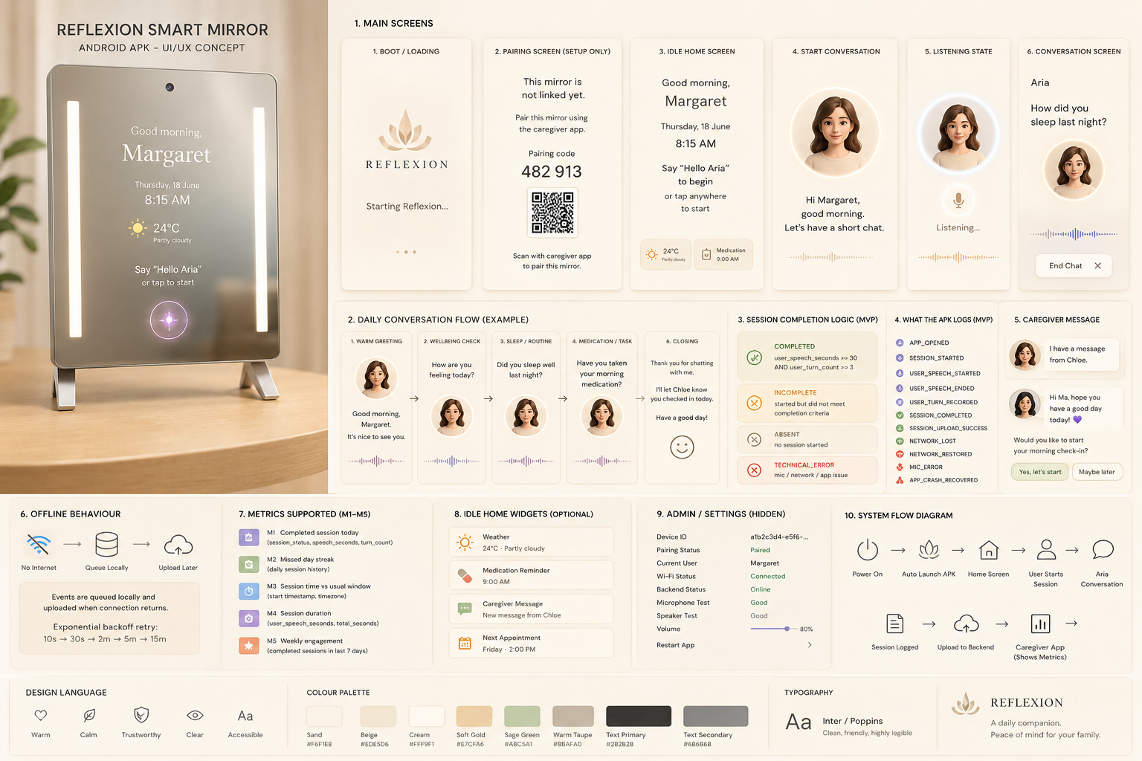

1. Hardware assumptions
Based on the current smart mirror spec, assume:
Screen: 10.1 inch
Resolution: 1920 × 1080, likely displayed in portrait orientation
OS: Android 14
RAM: 4GB
ROM: 32GB
Camera: 13MP
Microphone: 4-microphone linear array
Speakers: 3W × 2
Wi-Fi: Wi-Fi 6
Bluetooth: 5.4
Touchscreen: No
Mirror size: about 301mm × 401mm
Installation: desktop or wall mount
Important implication: do not design the MVP around touch.
Everything important must work through:
voice
automatic scheduled prompt
caregiver app trigger
physical/admin setup flow if needed
Touch can be optional only if the vendor later confirms touch support.

2. App architecture
Recommended MVP architecture:
Native Android APK shell
+
WebView conversation interface
+
Native device/session logging layer
Structure:
Reflexion Mirror APK
├── Native Android layer
│ ├── auto-launch on boot
│ ├── full-screen / kiosk mode
│ ├── device pairing
│ ├── local config storage
│ ├── microphone permission
│ ├── speaker output
│ ├── network monitoring
│ ├── offline queue
│ ├── session event logging
│ ├── crash recovery
│ └── backend API calls
│
└── WebView or native conversation UI
├── home screen
├── Aria conversation
├── listening state
├── captions
└── session end screen
For MVP, WebView is okay if the conversation interface already exists on web. But the APK must still own the device-level functions: boot, pairing, permissions, offline queue, and session logs.
The web app should not be the only thing controlling the mirror.

3. Visual design direction
The smart mirror UI should match the beige professional caregiver aesthetic from the spec image.
Use this design language:
Warm
calm
clean
premium
caregiver-friendly
non-medical
elderly-readable
minimal
Suggested palette:
Background cream: #FFF9F1
Sand: #F6F1E8
Warm beige: #EDE5D6
Soft gold: #E7CFA6
Sage green: #ABC5A1
Warm taupe: #BBAFA0
Text primary: #282828
Text secondary: #686868
Alert amber: soft muted orange, not harsh yellow
Alert red: muted coral/red, not emergency-hospital red
Typography:
Large font
High contrast
No tiny UI
No crowded text
No medical-looking tables
No neon tech theme
Main mirror screen should look like:
Good morning,
Margaret

Thursday, 18 June
8:15 AM

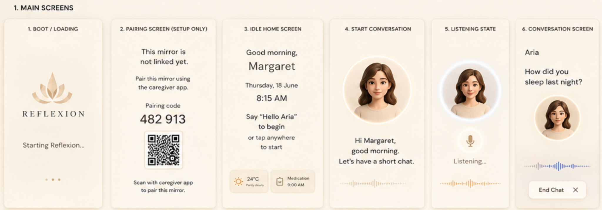

Say “Hello Aria”
to begin
Optional widgets should be small and soft:
24°C Partly cloudy
Medication 9:00 AM
Message from Chloe
Avoid showing caregiver status on the mirror:
Do not show: Doing Well / Worth Checking / Needs Attention
Do not show: cognitive score
Do not show: dementia risk
Do not show: red warnings to elderly user
Those belong in the caregiver app, not on the mirror.

4. Orientation and screen sizing
Although the panel resolution may be 1920 × 1080, the physical mirror is portrait.
Please build assuming:
Primary layout: portrait
Target canvas: 1080 × 1920
Safe area: central 80% of screen
Large readable text
Minimal edge content
If Android reports the display as landscape, the APK should support forced portrait rotation or vendor-level screen rotation.
Main text sizes:
Greeting name: 52–72sp
Date/time: 28–40sp
Prompt text: 30–42sp
Small widget text: 18–24sp
Because the mirror surface reduces contrast, keep the interface simple and bright.

5. Core app behaviour
When the mirror powers on:
Power on
→ Android boots
→ Reflexion APK auto-launches
→ App enters full-screen/kiosk mode
→ App checks device pairing and internet
→ App shows home mirror screen
→ Elderly user says “Hello Aria”
→ Daily conversation starts
→ APK records session metrics
→ APK uploads logs to backend
→ App returns to idle mirror screen
The user should not need to:
open an app
swipe around Android
type a password
click tiny buttons
deal with browser tabs
exit popups
log in repeatedly

6. Required screens

Screen 1: Boot / loading screen
Display:
Reflexion

Starting Reflexion...
Visual style:
cream background
soft gold logo
small loading dots
no dark tech theme
App checks:
device ID exists?
paired to a user?
internet connected?
backend reachable?
microphone permission granted?
speaker available?
current time/timezone correct?
Routes:
paired and online → home screen
not paired → pairing screen
offline → offline home mode
mic issue → setup/error screen

Screen 2: Pairing screen
Only shown during setup.
Display:
This mirror is not linked yet.

Pair this mirror using the caregiver app.

Pairing code:
482 913

[QR code]

Scan with the caregiver app to pair this mirror.
Because the mirror may not have touch, pairing must be handled externally through the caregiver app.
Flow:
APK requests pairing code from backend
APK displays code + QR
Caregiver app scans QR or enters code
Backend links device to elderly user
APK polls backend every few seconds
Once paired, APK downloads config
APK goes to home screen
Store locally:
device_id
patient_id
nurse_id
auth token
Patient name
language
timezone
voice settings
wake window
mirror config

Screen 3: Idle home screen
This is the default screen.
Display:
Good morning,
Margaret

Thursday, 18 June
8:15 AM

Say “Hello Aria”
to begin
Optional widgets:
Weather
Medication reminder
Caregiver message waiting
Next appointment
Since touchscreen may not exist, do not say “tap anywhere” unless we confirm touch. Use voice-first copy:
Say “Hello Aria” to begin.
If wake word is not ready for MVP, use scheduled prompting:
At 8:30 AM:
“Good morning Margaret. Would you like to start your morning check-in?”

Screen 4: Start conversation screen
Display:
Hi Margaret,
good morning.

Let’s have a short chat.
Show:
Aria avatar / soft circle
subtle waveform
mic indicator

Screen 5: Listening state
When the mic is active, make it obvious.
Display:
I’m listening...
Visual:
soft glowing circle
microphone icon
gentle waveform
Privacy requirement:
Never record silently.
Always show listening state when active.

Screen 6: Conversation screen
Display:
Aria

How did you sleep last night?

[Listening...]
Keep text short. One question at a time.
Do not show the full transcript unless needed. Captions are useful, but keep them simple.

Screen 7: Closing screen
Display:
Thank you for chatting with me.

I’ll let Chloe know you checked in today.

Have a good day.
Then return to home screen.

Screen 8: Offline screen
If no internet:
Reflexion is offline right now.

You can still complete your check-in.
I’ll update your caregiver once we’re connected again.
The APK should queue events locally and upload later.

Screen 9: Admin/settings screen
Because there may be no touchscreen, admin access should not depend only on hidden taps.
Options:
USB keyboard shortcut
caregiver app remote admin mode
vendor hardware button if available
ADB/debug during development
Admin screen should show:
Device ID
Pairing status
Current user
Wi-Fi status
Backend status
App version
Android version
Microphone test
Speaker test
Camera status
Volume
Brightness
Reset pairing
Upload logs
Restart app
Force sync

7. Daily conversation flow
MVP session length: 2–4 minutes.
The conversation should feel like a gentle check-in, not a test.
Example flow:
1. Greeting
“Good morning Margaret. It’s nice to see you.”

2. Wellbeing
“How are you feeling today?”

3. Sleep/routine
“Did you sleep well last night?”

4. Medication/task
“Have you taken your morning medication?”

5. Light memory / day-planning prompt
“What is one thing you plan to do today?”

6. Closing
“Thank you for chatting with me. I’ll let Chloe know you checked in today.”
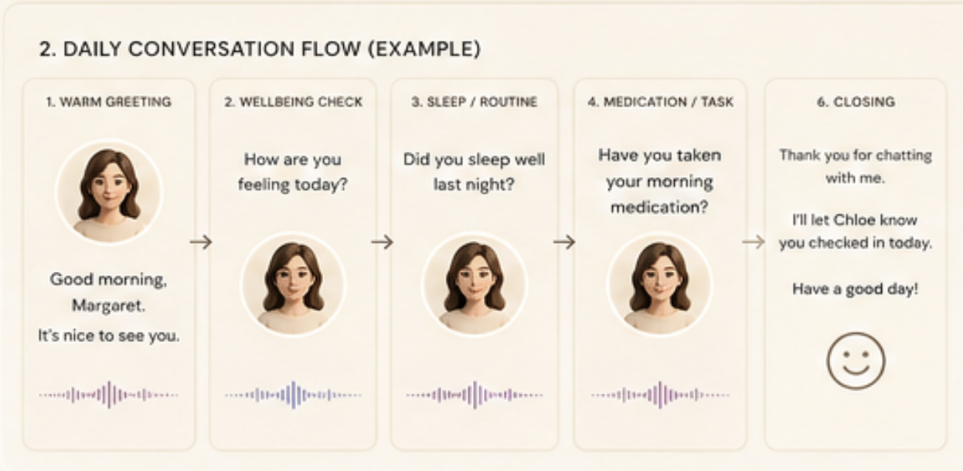
Important:
No diagnosis language.
No “memory test” wording.
No dementia wording.
No scary alerts.
Use:
morning chat
daily check-in
short conversation
routine
wellbeing
Avoid:
cognitive assessment
dementia screening
decline detected
abnormal result

8. Voice-first interaction
Since the mirror likely has no touchscreen, the MVP should support at least one of these:

Option A: Wake phrase
User says: “Hello Aria”
App starts session

Option B: Scheduled prompt
At configured time, Aria gently prompts:
“Good morning Margaret. Would you like to start your check-in?”
User can answer:
“Yes”
“Okay”
“Start”
“Not now”
“Later”

Option C: Caregiver-triggered prompt
From caregiver app:
Ask Aria to check in with Margaret
Mirror says:
“Margaret, Chloe asked me to check in. Would you like to have a short chat?”
For MVP, if wake-word detection is too complex, use scheduled prompt + caregiver trigger first.

9. Session completion logic
For MVP, do not depend on word count yet.
A session is completed if:
user_speech_seconds >= 30
AND
user_turn_count >= 3
Definitions:
completed:
user spoke for at least 30 cumulative seconds
and gave at least 3 responses

incomplete:
session started but did not meet completion criteria

Absent: [seems not necessary]
no session started that day

technical_error:
mic/backend/app/network issue made data unreliable
Important:
technical_error must not count as cognitive decline
technical_error should be shown to caregiver as device issue

10. Raw data the APK must collect
The APK should send raw logs to backend. Backend calculates caregiver status.
Minimum session payload:
{
"session_id": "uuid",
"device_id": "uuid",
"patient_id": "uuid",
"started_at": "2026-06-18T08:15:00+08:00",
"ended_at": "2026-06-18T08:18:40+08:00",
"timezone": "Asia/Singapore", [redundant]

"session_status": "completed",
"total_session_seconds": 220,
"user_speech_seconds": 74.5,
"aria_speech_seconds": 82.1,
"user_turn_count": 5,
"ai_turn_count": 6,

"start_source": "wake_phrase", [not gonna add yet cuz rn its only type A]
"language": "en-SG",
"app_version": "1.0.0",
"network_status": "online", [doesnt make sense]
"technical_error": false
}
Phase 2 fields:
{
"word_count": 95,
"wpm": 77.0,
"transcript_available": true,
"near_silent": false,
"asr_confidence": 0.84
}
Do not require Phase 2 fields for MVP.

11. Event logs
Please log events throughout the session, not only at the end.
Events needed:
APP_OPENED
APP_BOOT_STARTED
APP_READY
PAIRING_STARTED
PAIRING_COMPLETED
SESSION_STARTED
ARIA_PROMPT_STARTED
ARIA_PROMPT_ENDED
USER_SPEECH_STARTED
USER_SPEECH_ENDED
USER_TURN_RECORDED
SESSION_COMPLETED
SESSION_INCOMPLETE
SESSION_UPLOAD_SUCCESS
SESSION_UPLOAD_FAILED
NETWORK_LOST
NETWORK_RESTORED
MIC_PERMISSION_MISSING
MIC_ERROR
BACKEND_ERROR
APP_CRASH_RECOVERED
CAREGIVER_MESSAGE_RECEIVED
CAREGIVER_MESSAGE_PLAYED
Event format:
{
"event_id": "uuid",
"device_id": "uuid",
"elderly_user_id": "uuid",
"session_id": "uuid",
"event_type": "USER_SPEECH_ENDED",
"timestamp": "2026-06-18T08:16:12+08:00",
"metadata": {
"duration_seconds": 7.4
}
}
This is very important for pilot debugging.
If a caregiver says “the mirror did not work,” we need to know whether:
Wi-Fi failed
backend failed
mic failed
speaker failed
ASR failed
app crashed
user did not respond
user started but stopped
upload failed

12. Backend API endpoints
The APK needs these endpoints.

Register device
POST /mirror/devices/register
Request:
{
"hardware_serial": "ABC123",
"app_version": "1.0.0",
"android_version": "14",
"model": "Mirror 10.1 Smart Mirror"
}
Response:
{
"device_id": "uuid",
"pairing_code": "482913",
"pairing_qr_url": "..."
}

Check pairing status
GET /mirror/devices/{device_id}/pairing-status
Response:
{
"paired": true,
"elderly_user_id": "uuid",
"caregiver_id": "uuid",
"auth_token": "..."
}

Fetch mirror config
GET /mirror/devices/{device_id}/config
Response:
{
"elderly_display_name": "Margaret",
"preferred_language": "en-SG",
"timezone": "Asia/Singapore",
"wake_window": {
"start": "07:00",
"end": "10:00"
},
"voice": {
"speed": 0.9,
"volume": 0.8
},
"conversation_mode": "daily_checkin",
"scheduled_prompt_time": "08:30"
}

Start session
POST /mirror/sessions/start
Request:
{
"device_id": "uuid",
"elderly_user_id": "uuid",
"started_at": "2026-06-18T08:15:00+08:00",
"start_source": "wake_phrase"
}
Response:
{
"session_id": "uuid"
}

Upload event
POST /mirror/events
Request:
{
"session_id": "uuid",
"event_type": "USER_TURN_RECORDED",
"timestamp": "2026-06-18T08:16:12+08:00",
"metadata": {
"speech_seconds": 7.4
}
}

Complete session
POST /mirror/sessions/{session_id}/complete
Request:
{
"ended_at": "2026-06-18T08:18:40+08:00",
"session_status": "completed",
"total_session_seconds": 220,
"user_speech_seconds": 74.5,
"user_turn_count": 5,
"aria_turn_count": 6,
"technical_error": false
}

Fetch caregiver messages
GET /mirror/devices/{device_id}/pending-messages
Response:
{
"messages": [
{
"message_id": "uuid",
"from": "Chloe",
"text": "Hi Ma, hope you have a good day today!",
"play_after": "2026-06-18T08:00:00+08:00"
}
]
}

Mark caregiver message as played
POST /mirror/messages/{message_id}/played
Request:
{
"played_at": "2026-06-18T08:22:00+08:00"
}

13. Offline handling
The mirror must still work offline.
If internet drops:
Do not crash.
Do not freeze.
Do not lose the session.
Do not show scary error text.
Instead:
Save session locally.
Queue all events.
Upload when internet returns.
Retry schedule:
10 seconds
30 seconds
2 minutes
5 minutes
15 minutes
Offline queue should store:
session_start
session_events
session_complete
technical logs
caregiver message played status

14. Local storage
Use local storage for:
device_id
auth token
paired profile
last known config
offline queue
session logs
error logs
last successful sync
Suggested:
DataStore: config/settings
Room/SQLite: event queue and session logs
Encrypted storage: auth tokens

15. Caregiver message playback
For MVP, caregiver messages should play only at the next check-in, not randomly interrupt the elderly user.
Flow:
Caregiver sends message
Backend stores message
APK fetches pending messages
At next session start, Aria says:
“I have a message from Chloe.”
Then reads the message.
Then asks:
“Would you like to start your morning check-in?”
After playing, APK sends:
message_played timestamp
message_id
device_id

16. Metrics supported by the APK

The APK does not calculate the final caregiver status. Backend does that.
The APK only needs to provide raw data for these MVP metrics:

M1: Completed session today
Required data:
session_status
started_at
ended_at
user_speech_seconds
user_turn_count

M2: Missed day streak
Required data:
daily completed session history

M3: Session time vs usual window [can implement later]
Required data:
session start timestamp
timezone

M4: Session duration [Captured in conversation.status also same as M1?]
Required data:
user_speech_seconds
total_session_seconds

M5: Weekly engagement
Required data:
completed sessions over time
Important:
Backend calculates baseline.
Backend calculates amber/red/green.
Backend sends caregiver notifications.
APK should not hardcode alert thresholds.
This allows us to change thresholds later without updating every mirror APK.

17. Handling errors gracefully

No user response
Aria:
No worries, we can try again.
Reprompt once.
If still no answer:
That’s alright. I’ll check in with you again later.
Mark as incomplete.

User stops halfway
Mark as:
incomplete
Store:
user_speech_seconds
turn_count
session duration
reason = timeout / stopped / no_response

Backend unavailable
Continue local session if possible.
At end:
save locally
upload later

Microphone error
Display:
I’m having trouble hearing you.
Please check the microphone or restart Reflexion.
Log:
MIC_ERROR
technical_error = true

App crash
On next launch:
detect unfinished session
mark as technical_error or incomplete
upload crash log
restart home screen

18. Privacy rules
Because this may sit in someone’s bedroom or vanity area:
Do not record silently.
Do not run continuous recording unless explicitly designed and consented.
Show mic-active state clearly.
Prefer tap/scheduled/wake interaction over always-on recording.
Store derived metrics where possible.
If raw audio is stored, encrypt it.
Allow audio retention settings later.
Do not show clinical risk language on the mirror.
User-facing wording:
Reflexion uses your short daily chats to help your caregiver know you checked in.
Avoid:
Reflexion monitors you for dementia.
Reflexion detected cognitive decline.
You seem abnormal today.

19. What not to build for MVP
Do not spend time on:
dementia scoring
clinical diagnosis
noun imageability
type-token ratio
disfluency rate
language coherence
facial recognition
camera-based monitoring
complex games
caregiver analytics on the mirror
PDF GP summaries
advanced charts
MVP should be:
beautiful mirror UI
daily voice check-in
session logging
backend upload
offline queue
caregiver message playback
admin diagnostics

20. Build milestones

Milestone 1: APK shell
Deliver:
auto-launch APK
full-screen mirror interface
portrait layout
home screen
pairing screen
offline screen
basic admin screen

Milestone 2: Conversation
Deliver:
Aria starts daily check-in
voice input works
speaker output works
listening state visible
session ends cleanly

Milestone 3: Logging
Deliver:
session_start
session_end
speech duration
turn count
session status
event upload
offline queue

Milestone 4: Pilot readiness
Deliver:
crash recovery
network recovery
caregiver message playback
remote config fetch
device diagnostics
logs export/upload

21. MVP acceptance criteria
The APK is ready for pilot only when:
1. Mirror boots directly into Reflexion.
2. App stays full-screen.
3. UI matches warm beige professional mirror theme.
4. Elderly user can start check-in without touch.
5. Aria conducts a 2–4 minute daily conversation.
6. Mic and speaker work reliably.
7. APK records user speech duration.
8. APK counts user turns.
9. APK classifies completed vs incomplete.
10. APK uploads session data to backend.
11. APK queues data offline.
12. APK recovers after crash/restart.
13. Admin can test mic, speaker, Wi-Fi, backend, and pairing.
14. Backend can use uploaded data for caregiver app M1–M5 metrics.

22. Final product direction
Please build it as:
A calm, premium, beige smart mirror companion
that elderly users can speak to naturally every day,
while quietly giving caregivers reliable check-in data.
Not:
A dark tech dashboard.
A medical device interface.
A touchscreen tablet app.
A browser opened behind a mirror.

